Full Stack Job Portal



Group ID: G-08

Session: BSIT Fall 2021 to 2025

Project Supervisor: Prof. Irfan Shabbir

Group Members

M Saram Sarfraz Sharwani | 2021-MO-134 | (063768)
Syed Rabees Ali Shah | 2021-MO-135 | (063797)
Babar Hassan | 2021-MO-136 | (063758)

A DOCUMENTATION SUBMITTED IN PARTIAL FULFILLMENT OF THE DEGREE OF BS HONOURS IN INFORMATION TECHNOLOGY
FROM
DEPARTMENT OF THE INFORMATION TECHNOLOGY & COMPUTER SCIENCE,
GOVT. M.A.O GRADUATE COLLEGE, LAHORE AFFILIATED WITH UNIVERSITY OF THE PUNJAB, LAHORE
CERTIFICATION

This is to certify that M Saram Sarfraz Sharwani (Roll No. 063768), Syed Rabees Ali Shah (Roll No. 063797), and Babar Hassan (Roll No. 063758) have successfully submitted the final year project titled: "Full Stack Job Portal" at the department of the information technology & computer science, govt. M.A.O. graduate college, Lahore affiliated with university of the Punjab, Lahore, to fulfill the partial requirements for the degree of BS in Information Technology.

PROF. IRFAN SHABBIR

HEAD OF DEPARTMENT,
INFORMATION TECHNOLOGY & COMPUTER SCIENCE, GOVERNMENT, M.A.O GRADUATE COLLEGE, LAHORE.

Approved By:

(For Office Use Only)

ACKNOWLEDGEMENT

We would like to thank Almighty ALLAH, The Most Merciful, for providing us with the strength, knowledge, and determination to complete this project. We also want to express our highest respect and gratitude to The Holy Prophet MUHAMMAD (SAW), whose teachings have been our inspiration and guide.

We would like to thank Professor Irfan Shabbir, Head of Department of Information Technology & Computer Science, Govt. M.A.O Graduate College, Lahore, for his valuable guidance, constructive criticism, and timely support. His expertise and dedication have played a significant role in the development of our project, Full Stack Job Portal, and in guiding us through the issues that we faced on the way.

A special thank you to our parents, whose moral support, emotional and financial, has been our greatest strength throughout this journey. Their patience, sacrifices, and trust in us have been an inspiration.

We would also like to thank the faculty and staff of Govt. M.A.O Graduate College, Lahore, whose wisdom, guidance, and dedication have greatly helped us in our academic and professional growth.

Finally, we value the joint efforts of our team members, whose hard work and dedication have led to this project's success.

Group Members
M Saram Sarfraz Sharwani
Syed Rabees Ali Shah
Babar Hassan

ABSTRACT

Full Stack Job Portal is an online system that brings job seekers and employers together in an effective manner. Conventional job search processes are ineffective and time consuming, and employers are burdened with application and recruitment processes. The project focuses on optimizing job search and recruitment through an easy to use, real time, and secure system.

The system allows job seekers to register account, search for jobs with advanced filters, apply for jobs, and monitor application status. Recruiter can post job vacancies, view applicants, update job statuses, and manage recruitment effortlessly. Using React JS, Express JS, Tailwind CSS, Supabase, Clerk authentication, and Shadcn UI, the system provides a responsive UI, real time updates, and secure authentication.

In developing the system, we focused on using a scalable design, easy navigation, and strong security features. Testing proved that the system maximizes job search efficiency and simplifies employer processes compared to conventional platforms.

Overall, the Full Stack Job Portal offers an optimized platform for job seekers and recruiters, minimizing hiring issues and optimizing the recruitment process.

Table of Content

Chapter 1: Introduction 1
1.1 Project Introduction 2
1.2 Project Background 2
1.3 Problem Statement 2
1.4 Project Goals 2
1.5 Project Objectives 3
1.6 Project Scope 3
1.7 Project Limitations 3
1.8 Project Assumptions 3
Chapter 2: Literature Review 4
2.1 Job Portals & Recruitment Websites Evolution 5
2.2 Full Stack Job Sites Currently Available 5
2.3 Comparison of Full Stack Job Portals 5
2.4 Challenges Confronting Job Seekers & Recruiters 5
2.5 AI & Machine Learning in Job Portals 5
2.6 Full Stack Job Portal Technological Frameworks 5
2.7 Gaps and Innovations in Existing Platforms 6
2.8 Role of social media & Networking in Job Hunting 6
2.9 Limited access to career guidance 6
2.10 Conclusion 6
Chapter 3: Project Analysis 7
3.1 Introduction to Project Analysis 8
3.2 System Overview & Requirements Analysis 8
3.3 Functional Requirements 8
3.4 Non Functional Requirements 8
3.5 Project Schedule & Estimations 9
3.6 Project Schedule Management 9
3.6.1 Gantt Chart 9
3.6.2 CPM (Critical Path Method) 10
3.6.3 PERT Chart (Program Evaluation and Review Technique Chart) 11
3.7 Project Cost and Effort Estimation 12
3.7.1 Function Point (FP) Calculation 12
3.7.2 COCOMO Model 13
3.7.3 Project Cost Estimation 14
3.8 Use Case Analysis 14
Use Case 1: Account Registration 15
Use Case 2: Manage Account Use Case 16
Use Case 3: Adding Company Use Case 17
Use Case 4: Posting Jobs Use Case 18
Use Case 5: Delete Job Listings and Update Job Hiring Status Use Case 19
Use Case 6: Search and View Job Detail Use Case 20
Use Case 7: Apply for Job and Track Application Status Use Case 21
Use Case 8: View Candidate Applications and Shortlist Use Case 22
Use Case 9: Admin View All Users on Admin Dashboard Use Case 23
Use Case 10: Ban/Unban Users and Delete User Use Case 24
Use Case 11: View All Jobs and Delete Job Use Case 25
Chapter 4: Project Design Specification 26
4.1 System Architecture Diagram 27
4.2 Data Flow Diagram 28
4.2.1 Data Flow Diagram (DFD) Level 0 28
4.2.2 Data Flow Diagram (DFD) Level 1 28
4.2.3 Data Flow Diagram (DFD) Level 2 29
4.3 Entity Relationship Diagram (ERD) 30
4.4 Class Diagram 31
4.5 Sequence Diagrams 32
4.5.1 Candidate Authentication & Onboarding Sequence Diagram 32
4.5.2 Candidate Job Search & Discovery Sequence Diagram 33
4.5.3 Candidate Job Application Process Sequence Diagram 33
4.5.4 Profile Management Sequence Diagram 34
4.5.5 Recruiter Profile Management Sequence Diagram 34
4.5.6 Recruiter Job Posting Process Sequence Diagram 35
4.5.7 Recruiter Application Status Updates Sequence Diagram 35
4.5.8 Admin Authentication & Access Sequence Diagram 36
4.5.9 Admin User Account Management Sequence Diagram 36
4.5.10 Admin Job Postings Oversight/Delete Sequence Diagram 37
4.6 Collaboration Diagram 38
4.7 Activity Diagram 39
4.7.1 Candidate Activity Diagram 39
4.7.2 Recruiter Activity Diagram 40
4.7.3 Admin Activity Diagram 41
4.8 State Transition Diagram 42
4.9 Component Diagram 43
Chapter 5: Testing and Implementation 44
5.1 Project Testing 45
5.2 Types of Testing Performed on Job Portal 45
5.3 Test Cases and Scenarios 45
5.4 Functional Test Cases 45
5.4.1 User Registration Test Case 45
5.4.2 User Login Test Case 46
5.4.3 Job Posting Test Case (For Recruiters) 46
5.4.4 Job Search Test Case (For Job Seekers) 46
5.4.5 Job Application Test Case (For Job Seekers) 47
5.4.6 Block/Unblock User (Admin) 47
5.4.7 Delete User (Admin) 47
5.4.8 Delete Job (Admin) 48
5.4.9 Search User/Job by Email (Admin) 48
5.4.10 Change Job Status (Open/Closed) (Recruiter) 48
5.4.11 View Applicants for Job (Recruiter) 49
5.4.12 Save Job for Later (Job Seeker) 49
5.4.13 View Saved Jobs (Job Seeker) 49
5.5 Non Functional Test Cases 50
5.5.1 Performance Test Case (System Load Handling) 50
5.5.2 Security Test Case (Unauthorized Access Prevention) 50
5.5.3 Usability Test Case (Mobile Responsiveness) 50
5.6 Project Implementation 51
5.6.1 Homepage (Landing Page) Preview 51
5.6.2 Registration Page Preview 52
5.6.3 Login Page Preview 53
5.6.4 Account Manager Page Preview 54
5.6.5 Jobs Page Preview 55
5.6.6 Posting Job Page Preview 56
5.6.7 Managing Applications Page Preview 57
5.6.8 Manage Jobs Delete/Update Page Preview 58
5.6.9 Saved Jobs Page Preview 59
5.6.10 Admin Pannel User Manager Page Preview 60
5.6.11 Admin Pannel Jobs Manager Page Preview 61
Chapter 6: Deployment & Maintenance 62
6.1 Introduction to Deployment & Maintenance 63
6.2 Deployment Diagram 63
6.3 Database Configuration & Data Migration 64
6.4 Security & Compliance During Deployment 64
6.5 API Integration & Cloud Services 64
6.6 Post Deployment Monitoring & Analytics 64
6.7 Backup & Disaster Recovery Plan 64
6.8 Update & Feature Rollout Process 65
6.9 Maintenance of Security Policies 65
6.10 Final Testing Before Launch 65
References 66

Chapter 1: Introduction

Project Introduction
The The HIRED Job Portal is a user friendly website designed to connect job seekers and employers. Job seekers can easily search and apply for jobs using filters like location, company, and job type. Employers can quickly post job openings and review applicants, making the hiring process straightforward. The portal supports students at all education levels matric, intermediate, and bachelor by offering relevant job listings, internships, and resources to help build their skills. With a clean design and smooth navigation, HIRED makes job searching and hiring simple, fast, and accessible for everyone.

Project Background
Job hunting and hiring have changed a lot over the years. While online platforms made things easier, many people still struggle to find the right jobs or candidates. Our project, HIRED Full Stack Job Portal, solves this by using modern tools like React JS, Tailwind CSS, Supabase, Clerk, and Shadcn UI. It allows job seekers to create profiles, upload resumes, search and apply for jobs, and track their applications in real time. Recruiters can post jobs, manage listings, review applicants, and update hiring statuses. The platform is fast, secure, and easy to use, designed to make the hiring process smoother for everyone.

Problem Statement
In 2025, job seekers still struggle to find relevant jobs, and employers face delays due to outdated hiring systems. Most job portals lack real time updates, are hard to use, and don’t support flexible roles for students or fresh graduates. Many platforms also fail to match jobs with user profiles or offer a smooth hiring process. Our HIRED Full Stack Job Portal solves these problems using modern tools like React, Supabase, and Clerk. It provides real time job updates, smart filtering, quick applications, and an admin panel for secure platform management, making hiring faster, easier, and more accurate for everyone.

Project Goals
The goal of the HIRED Job Portal is to create a fast, modern, and user friendly platform that makes job searching and hiring easier for everyone. It connects job seekers with employers using secure login, real time updates, and smart filters. Job seekers can create profiles, upload resumes, and apply to jobs quickly. Employers can easily post jobs, manage applicants, and download resumes. Admins can manage the platform through a dedicated panel. This project aims to simplify the hiring process and support career growth using the latest full stack technologies.

Project Objectives
The goal of the HIRED Job Portal is to build a smart and user friendly platform where job seekers can easily find jobs and employers can hire the right candidates. It lets users search, apply, and track jobs based on their skills and interests. Employers can post jobs, view applicants, and manage hiring quickly. The system also supports internships and part time opportunities for students and fresh graduates. With a mobile friendly design using React, Tailwind CSS, Clerk, and Supabase, it works smoothly on all devices. Real time job suggestions and admin level controls ensure better results for all users.

Project Scope
The HIRED Job Portal is designed to make job hunting and hiring easier for students, fresh graduates, professionals, and companies. It lets job seekers create profiles, upload resumes, search jobs, apply, and track their applications. Employers can post jobs, manage applicants, and download resumes. The platform supports full time, part time, and internship roles. Real time updates, resume storage, admin control, and secure logins using Clerk are included. For now, it focuses on users in Pakistan.

Project Limitations
The HIRED Job Portal is currently a web based platform and does not have a native mobile app, though it works well on mobile browsers. Features like AI based job suggestions and employer verification are planned for future updates but are not included yet. The platform relies on third party services like Supabase and Clerk, so any downtime from them may affect availability. Resume creation and interview scheduling are handled outside the platform. It’s mainly built for general job roles and may not fully support highly specialized fields. Basic security is implemented, but full data privacy laws, end to end encryption, and fraud detection are areas for future improvement.

Project Assumptions
The HIRED Job Portal assumes that users will have a stable internet connection and use modern browsers like Chrome or Firefox. The platform is designed for both desktop and mobile web access but does not include a mobile app in the initial version. It expects active usage from job seekers and recruiters familiar with online job searching. Platform growth is assumed to come from user engagement, social media, and online promotion. Authentication is handled securely through Clerk. Users are expected to verify job details themselves, with fraud reporting tools improving over time. Regular updates, security patches, and backups are assumed to keep the system stable and secure.

Chapter 2: Literature Review

Job Portals & Recruitment Websites Evolution
Job searching has changed from newspapers and agencies to fast, online platforms. Earlier, it was hard for job seekers and companies to connect. Now, websites like Indeed, LinkedIn, and Rozee.pk allow people to search jobs, upload resumes, and get smart job recommendations. This digital shift has made hiring faster and easier for everyone.

Full Stack Job Sites Currently Available
Today’s top job portals like LinkedIn, Indeed, Glassdoor, and Rozee.pk use full stack technologies such as React, Node.js, PostgreSQL, and Firebase. These platforms help users upload resumes, search jobs, and connect with companies. Many also use AI to recommend jobs based on user profiles. They are powerful, scalable, and easy to use.

Comparison of Full Stack Job Portals
Each major job portal has its strengths and gaps. LinkedIn focuses on networking but can be complex. Indeed is simple but lacks deep job matching. Glassdoor shows company reviews but not smart job filters. Rozee.pk is great for Pakistan but doesn’t use real time data or AI. Our platform, HIRED, improves on these with real time updates, user friendly UI, role based access, and admin level control, making hiring and job hunting more modern and efficient.

Challenges Confronting Job Seekers & Recruiters
Even with online job portals, job seekers often face irrelevant listings, too many applicants for each role, fake job posts, and little to no feedback from companies. Recruiters struggle to filter resumes, verify candidates, and quickly find the right people. Platforms like HIRED aim to solve this by using filters, real time updates, and secure systems to improve the overall experience for both sides.

AI & Machine Learning in Job Portals
AI plays an important role in modern job portals. It helps match candidates to jobs based on skills, parse resumes, and even predict hiring trends. Some portals also use chatbots for interviews or scheduling. HIRED doesn’t yet include AI in the current release, but future versions will explore smart matching, fraud detection, and better job recommendations using AI tools.

Full Stack Job Portal Technological Frameworks
Job platforms today rely on fast and secure technology. HIRED uses React 18 and Tailwind CSS for the frontend, ensuring a clean and responsive design. The backend uses Node.js with Express, connected to Supabase with PostgreSQL for real time updates. Clerk handles secure login and role management. This modern full stack setup makes the portal reliable, scalable, and easy to maintain.

Gaps and Innovations in Existing Platforms
Even with modern job portals, issues like poor job matching, fake employer profiles, and no real way to test a candidate's skills still exist. Features like AI powered job suggestions, resume verification using secure tech, and skill based hiring tools are missing in most platforms. The HIRED portal is designed to fill these gaps with smart features in future updates to make hiring faster and more reliable.

Role of social media & Networking in Job Hunting
Social media plays a big role in hiring today. Platforms like LinkedIn, Facebook, and Twitter help candidates connect with companies and get jobs through referrals. They also let companies promote their brand and job openings. Future versions of HIRED can benefit by adding options to share jobs on social media and let users grow their network within the platform.

Limited access to career guidance
A big challenge for many job seekers especially students and fresh graduates is not knowing which career path to choose. Most job portals don’t offer proper guidance. Adding features like career tips, learning paths, and expert advice can make the experience more helpful. HIRED plans to include such sections to guide users toward better career decisions.

Conclusion
This chapter shows how job portals have improved recruitment but still lack key features like smart matching, verified employers, and career support. HIRED aims to fix these gaps with secure systems, modern design, role based access, and future plans for AI and learning tools. With the right updates, it can become a powerful and helpful platform for both job seekers and recruiters.

Chapter 3: Project Analysis

Introduction to Project Analysis
Project analysis plays a key role in planning and building any software system. It helps define what the system should do, how it should behave, and what users expect from it. In the case of the HIRED job portal, this stage helped us understand all user roles candidates, recruiters, and admins and their specific needs. It also allowed us to map out how data flows between the frontend, backend, and database. By analyzing these aspects early on, we ensured that the final design would be scalable, efficient, and aligned with the main goals of the project.

System Overview & Requirements Analysis
HIRED is designed to connect job seekers and employers through a simple yet powerful platform. Job seekers can sign up, complete their profiles, apply for jobs, and track application status, all from their dashboard. Recruiters can post jobs, review applications, and manage hiring workflows. The platform uses secure Clerk authentication, Supabase for real time data, and role based access to ensure users only access the features meant for their role. Features like search filters, resume uploads, and job tracking make the process smoother for both parties. Admins also get full control to monitor and manage users and jobs in the system.

Functional Requirements
To support all features, the platform includes several core functions. Users must register and log in securely through Clerk, with roles selected during onboarding (candidate, recruiter, or admin). Recruiters can post jobs with full details such as title, location, and skills required. Job seekers can search jobs using filters, save favorites, upload resumes, and apply with one click. Notifications are sent in real time to keep users updated on application status or new job postings. Admins have the ability to view, ban/unban, or delete users, as well as monitor job postings across the platform.

Non Functional Requirements
HIRED is built to be fast, secure, and user friendly. It performs well even with many users and jobs due to efficient queries and real time updates via Supabase. Security is enforced through JWT tokens, RLS (Row Level Security), and file storage protections. The interface is designed to work smoothly across all devices, including desktops and mobiles, with responsive layouts and modern UI using Tailwind and Shadcn. Accessibility features like keyboard support are also included. With continuous deployment on platforms like Vercel and Heroku, the system stays reliable, regularly backed up, and easy to maintain or scale.

Project Schedule & Estimations

This section explains how the project was planned and tracked using standard project management techniques, such as Gantt charts to visualize the timeline, Critical Path Method (CPM) to identify important tasks, Program Evaluation Review Technique (PERT) to estimate time based on uncertainty, Function Point (FP) calculation to measure system complexity, and COCOMO to estimate development effort and cost.

Project Schedule Management

Gantt Chart

A Gantt Chart is used to define tasks, assign deadlines, and track the project.

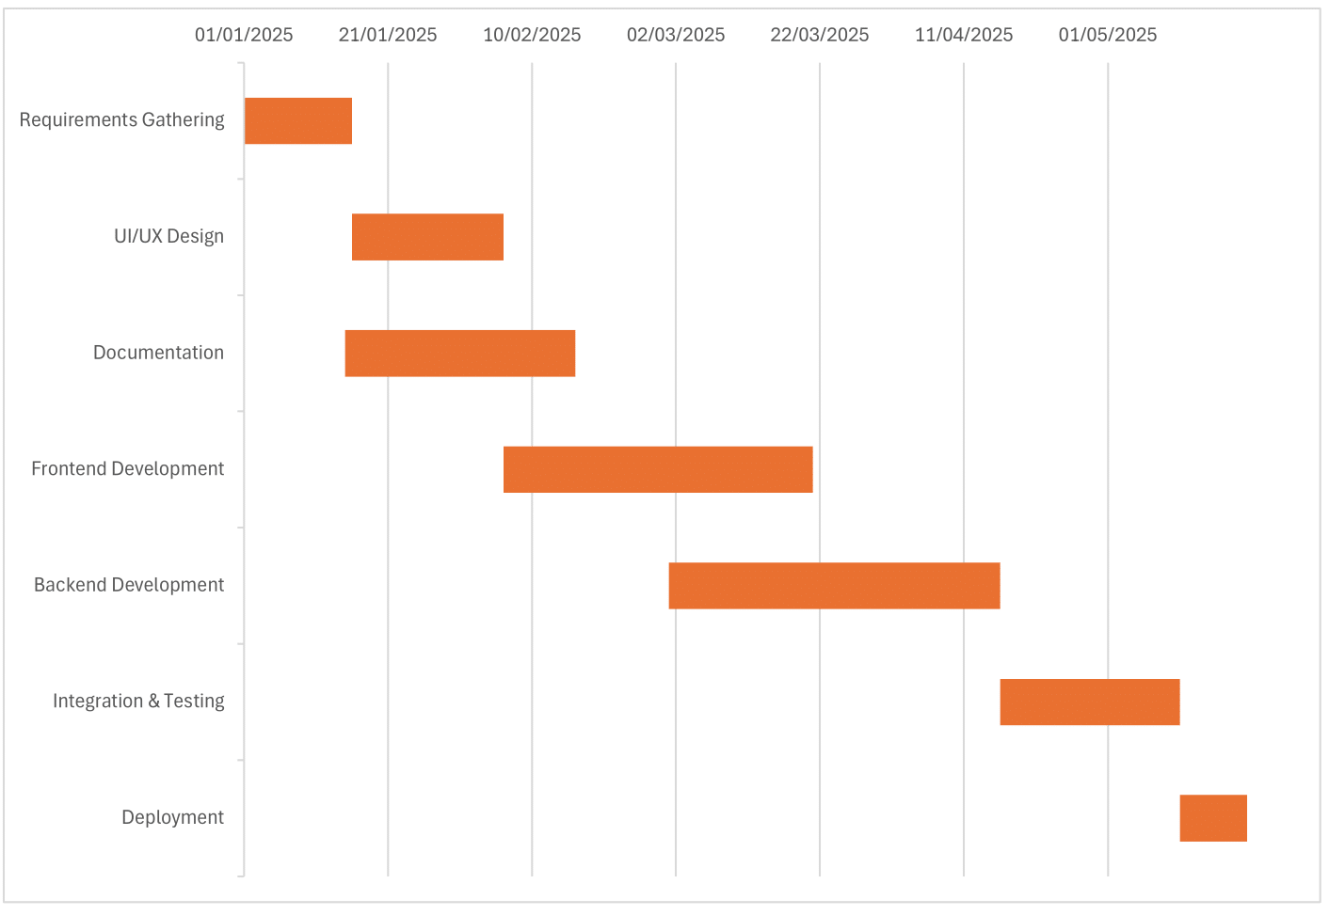
Figure 3.1: Gantt chart for Full Stack Job Portal Project

The table below summarizes the key phases, start and end dates, and duration of each phase:

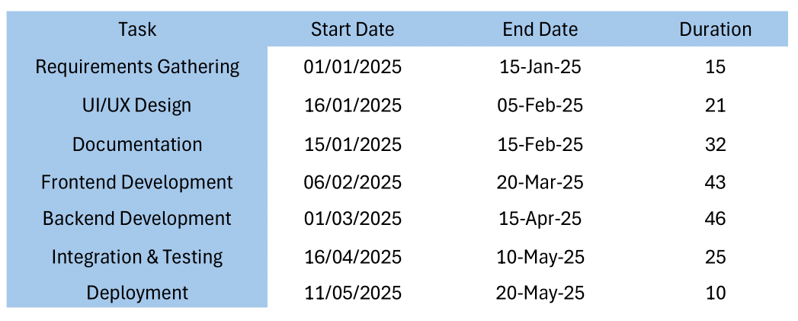
Table 3.1: Table of Gantt chart

CPM (Critical Path Method)

Critical Path Method is used to determine the order of the tasks that would be completed within time to prevent delay in the project. The development of the Full Stack Job Portal was structured into seven main phases, each with specific dependencies. The breakdown of tasks, durations, and dependencies is as follows:

Task ID | Task Name | Duration (Days)
A | Requirements Gathering | 15
B | UI/UX Design | 21
C | Documentation | 32
D | Frontend Development | 43
E | Backend Development | 46
F | Integration & Testing | 25
G | Deployment | 10
Table 3.2: Table to find CPM of Project

The Critical Path is determined by calculating the longest sequence of dependent tasks in the project. The following paths were analysed:

Path 1: A → C → E → F → G
A (15) + C (32) + E (46) + F (25) + G (10) = 128 Days
Path 2: A → B → D → F → G
A (15) + B (21) + D (43) + F (25) + G (10) = 114 Days
Since Path 1 takes 128 days, which is longer than Path 2 (114 days), it is identified as the Critical Path. This means that any delay in the tasks on Path 1 (A, C, E, F, G) will directly delay the project deadline.

PERT Chart (Program Evaluation and Review Technique Chart)
The PERT chart is a helpful tool that estimates how long tasks may take by considering uncertainty. Unlike CPM, which uses fixed times, PERT uses three estimates Optimistic, Most Likely, and Pessimistic, to better handle unexpected issues. This makes it useful for complex projects where problems like bugs or changing requirements can cause delays. In building the Full Stack Job Portal, PERT helped manage uncertain task durations, set more realistic time frames, spot possible delays early, and keep the project on track by understanding how tasks depend on each other.
The estimated time for each task is calculated using the following formula:

$$TE=\frac{(O+4M+P)}{6}$$

PERT Chart Breakdown Table:

Task ID | Task Name | Optimistic (O) | Most Likely (M) | Pessimistic (P) | Expected Time (TE)
A | Requirements Gathering | 12 | 15 | 18 | 15 Days
B | UI/UX Design | 18 | 21 | 25 | 21.17 Days
C | Documentation | 28 | 32 | 38 | 32.33 Days
D | Frontend Development | 38 | 43 | 50 | 43.33 Days
E | Backend Development | 42 | 46 | 53 | 46.17 Days
F | Integration & Testing | 22 | 25 | 30 | 25.33 Days
G | Deployment | 8 | 10 | 12 | 10 Days
Table 3.3: Breakdown Table to PERT Chart

By adding up the expected time for the main tasks (A → C → E → F → G), the total project duration comes out to around 128.83 days, which is about 4.3 months. This means that if everything goes as planned, the project can be finished in about 128 to 130 days, with a little flexibility for small delays.
PERT Chart of Job Portal:

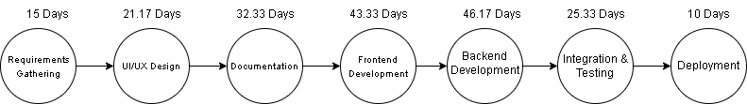
Figure 3.2: PERT Chart for Full Stack Job Portal Project

Project Cost and Effort Estimation
Effort and cost estimation is important in software projects to use resources well and finish on time. For the Full Stack Job Portal, we used two common methods: Function Point (FP) to check how complex the project is, and the COCOMO model to estimate the time and effort based on the code size. Since this is a student project with limited budget, we based our cost estimates on real expenses like internet, APIs, and software tools, instead of using high costs like professional salaries.

Function Point (FP) Calculation
Function Point Analysis is a method used to measure how complex a project is based on what it does for users, instead of counting lines of code. It focuses on the system's functions like inputs, outputs, data storage, and how it interacts with other systems. Each function type has a certain value, and these are measured using a standard method given by the International Function Point Users Group. This helps in understanding how big or complex a project is, no matter what coding language is used.

Function Type | Count | Complexity Weight | Total Points
External Inputs (EI) | 10 | 4 | 40
External Outputs (EO) | 8 | 5 | 40
External Interface Files (EIF) | 5 | 7 | 35
Internal Logical Files (ILF) | 6 | 10 | 60
External Queries (EQ) | 7 | 3 | 21
Total Function Points (FP) |  |  | 196 FP
Table 3.4: FP Calculation Table

Function Point Analysis helps measure how complex a software project is by looking at what it does for users. In our Job Portal, we counted 10 external inputs like user registration and job posting, each given a weight of 4, totaling 40 points. We had 8 outputs like showing job listings and application status, each rated at 5, totaling 40 points. The system also connects with 5 external files like authentication and logo storage, each with a weight of 7, adding up to 35 points. For internal files like user and job databases, we had 6, each rated at 10, making 60 points. Lastly, 7 search and data viewing features (external queries) were rated 3 each, totaling 21 points. Adding all of these, the total function points came to 196, which shows the project is medium to large in size. This means the system has a good level of complexity, with many user features, data handling, and outside connections, and would need around 15 to 20 hours of work per point to build.

COCOMO Model
The COCOMO Model is used to estimate how much effort and time is needed to complete the project. Since this is a student project, the estimation is based on personal learning and development time, using free or low cost tools like open source software and student hosting, and covering only basic expenses such as internet, hosting, and domain fees.
The Basic COCOMO formula is:

E = a(KLOC)^{b}

Where:

- E = Effort in person months
- KLOC = Thousands of Lines of Code (Estimated)
- a, b = Constants for Organic Software Development (a = 2.4, b = 1.05)

Estimated Code Size

Component | Lines of Code (LOC)
Frontend (React, Tailwind CSS) | 1000 LOC
Backend (Supabase, Clerk Authentication, API) | 1430 LOC
Total Code Size | 2430 LOC (2.43 KLOC)

Table 3.5: Code Size Estimation Table

Using the COCOMO formula:

E=2.4(2.43) ^{1.05}
E=2.4× 2.54
E = 6.10 person months

Project Cost Estimation

Since this is a student led project, professional developer salaries are not included. Instead, we estimate costs based on basic development expenses.

Breakdown of Actual Costs

Expense Category | Expense Category
Internet | 5,000 PKR
APIs/Hosting/Domain/DB | 2,000 PKR
Documentation | 6,000 PKR
Other Expenses (Electricity, Software Tools, etc.) | 1,500 PKR
Total Estimated Cost | 15,500 PKR

Table 3.6: Project Cost Estimation Table

Thus, the total project cost remains within 15,500 PKR, making it affordable and feasible for a student project.

Use Case Analysis
Use Case Analysis is a simple way to understand how users will interact with a system by showing what actions they can take and how the system should respond. It helps plan the features by showing user roles, actions, and their connections in a clear and visual format like diagrams. For the Full Stack Job Portal, we created different use cases to show how job seekers, recruiter and admin will use the platform to do tasks. Each use case explains what the goal is, who is involved, what steps are followed, and how the system reacts.

Use Case ID | UC_01
Use Case Name | Account Registration
Description | This use case allows users (job seekers and recruiters) to register an account on the job portal. The system collects necessary information, verifies user credentials, and grants access to the platform.
Primary Actor | Job Seeker, Recruiter
Secondary Actor | System
Pre-Condition | The user must have a valid email and internet access.
Post-Condition | The user receives a confirmation email and gains access to the platform.

Account Registration

Table 3.8: Use Case 1 Details Table

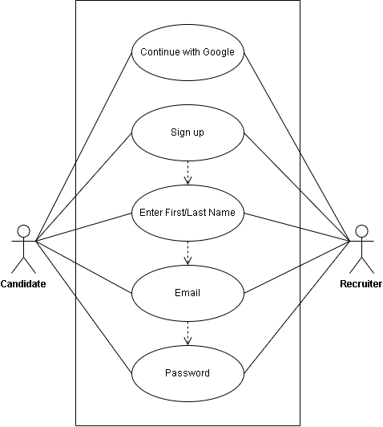

Figure 3.3: Account Registration Use Case Diagram

Manage Account Use Case

Use Case ID | UC_02
Use Case Name | Manage Account
Description | Users can edit personal details, update passwords, and delete accounts.
Primary Actor | Job Seeker, Recruiter
Secondary Actor | System
Pre-Condition | The user must be logged in.
Post-Condition | Changes are saved, or the account is deleted.

Table 3.9: Use Case 2 Details Table

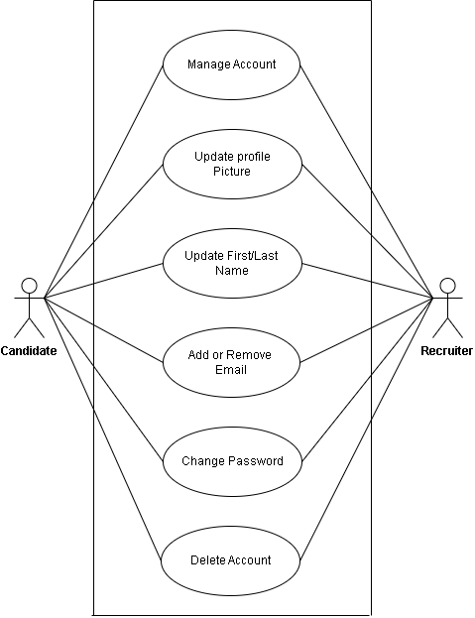

Figure 3.4: Manage Account Use Case Diagram

Adding Company Use Case
Use Case ID | UC_03
Use Case Name | Adding Company
Description | This use case allows recruiters to add their company details on the job portal during posting job. It ensures that all job postings are linked to a company, providing authenticity to job seekers.
Primary Actor | Recruiter
Secondary Actor | System
Pre-Condition | The recruiter must be logged in and verified before adding a company profile.
Post-Condition | The company is successfully added in the system and linked to job postings created by the recruiter.

Table 3.10: Use Case 3 Details Table

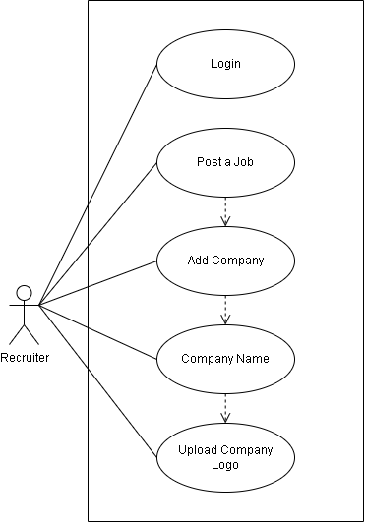
Figure 3.5: Adding Company Use Case Diagram

Posting Jobs Use Case
Use Case ID | UC_04
Use Case Name | Posting a Job
Description | Recruiters can post job openings, specifying details such as title, description, company, requirements, and location.
Primary Actor | Recruiter
Secondary Actor | System
Pre-Condition | The recruiter must have an active, verified account and a registered company profile.
Post-Condition | The job posting is saved in the database and displayed to job seekers.

Table 3.11: Use Case 4 Details Table

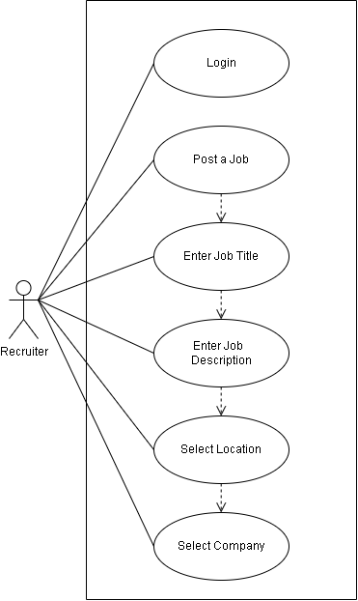

Figure 3.6: Posting Jobs Use Case Diagram

Delete Job Listings and Update Job Hiring Status Use Case
Use Case ID | UC_05
Use Case Name | Delete Job Listings and Update Job Hiring Status
Description | This use case allows recruiters to delete job listings or update the hiring status open, closed to keep job postings accurate.
Primary Actor | Recruiter
Secondary Actor | System
Pre-Condition | The recruiter must be logged in and have permission to manage job listings.
Post-Condition | The job listing is updated or removed, and job seekers no longer see closed positions.

Table 3.12: Use Case 5 Details Table

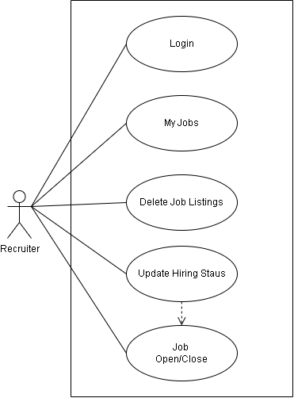

Figure 3.7: Delete Job Listings and Update Job Hiring Status Use Case Diagram

Search and View Job Detail Use Case
Use Case ID | UC_06
Use Case Name | Search and View Job Details
Description | Job seekers can search for job listings based on filters like job title, location, and company.
Primary Actor | Job Seeker
Secondary Actor | System
Pre-Condition | The job seeker must be logged in to access job listings.
Post-Condition | The job seeker is presented with relevant job listings and can view job details.

Table 3.13: Use Case 6 Details Table

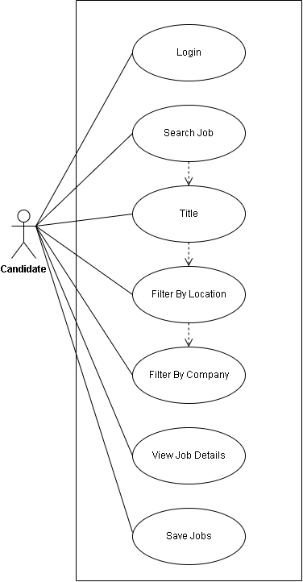

Figure 3.8: Search and View Job Detail Use Case Diagram

Apply for Job and Track Application Status Use Case
Use Case ID | UC_07
Use Case Name | Apply for a Job and Track Application Status
Description | Job seekers can submit applications and monitor their progress (Pending, Reviewed, Accepted, Rejected).
Primary Actor | Job Seeker
Secondary Actor | System
Pre-Condition | The job must be open for applications, and the job seeker must have a verified account.
Post-Condition | The application is submitted, and the job seeker can track its status.

Table 3.14: Use Case 7 Details Table

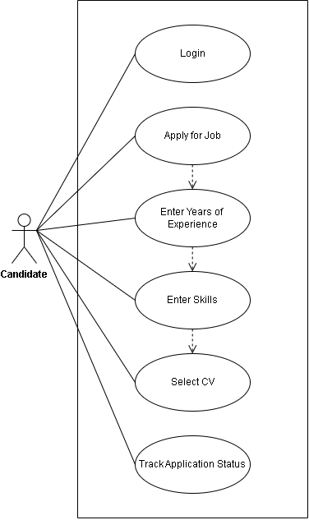

Figure 3.10: Apply for Job and Track Application Status Use Case

View Candidate Applications and Shortlist Use Case
Use Case ID | UC_08
Use Case Name | View Candidate Applications and Shortlist Candidates
Description | Recruiters can review applications, filter candidates, and shortlist them.
Primary Actor | Recruiter
Secondary Actor | System
Pre-Condition | The recruiter must have an active job listing with received applications.
Post-Condition | The recruiter successfully shortlists or rejects candidates.

Table 3.15: Use Case 8 Details Table
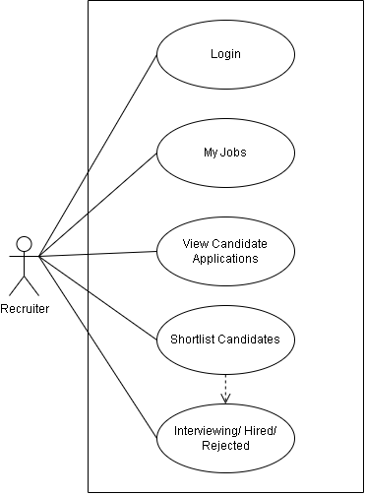

Figure 3.11: View Candidate Applications and Shortlist Candidates Use Case

Admin View All Users on Admin Dashboard Use Case
Use Case ID | UC_09
Use Case Name | Admin View All Users on Admin Dashboard
Description | The admin can view the list of all users registered on the platform, including both candidates and recruiters.
Primary Actor | Admin
Secondary Actor | System
Pre-Condition | Admin must be logged in with valid admin privileges.
Post-Condition | All users' data is fetched and displayed in the admin panel.

Table 3.16: Use Case 9 Details Table
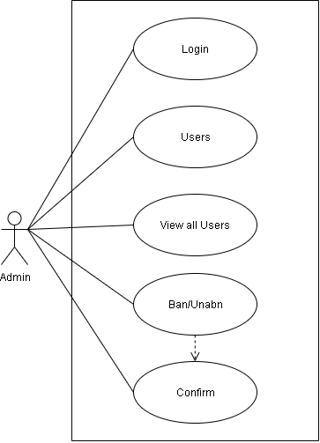

Figure 3.12: Admin View All Users on Admin Dashboard Use Case

Ban/Unban Users and Delete User Use Case
Use Case ID | UC_010
Use Case Name | Ban/Unban Users and Delete User
Description | Admin can ban or unban users to restrict or restore access, and can permanently delete users from the system.
Primary Actor | Admin
Secondary Actor | System
Pre-Condition | Admin is logged in and has access to the user management panel.
Post-Condition | User status is updated (banned/unbanned) or the user is deleted.

Table 3.17: Use Case 10 Details Table

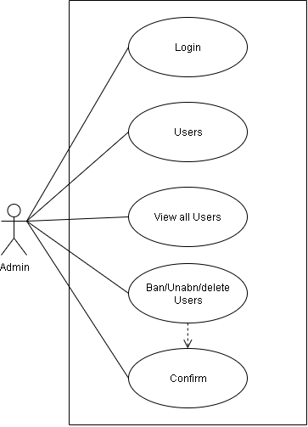

Figure 3.13: Ban/Unban Users and Delete User Use Case

View All Jobs and Delete Job Use Case
Use Case ID | UC_011
Use Case Name | View All Jobs and Delete Job
Description | The admin can view all job postings on the platform and has the ability to delete any job post if necessary.
Primary Actor | Admin
Secondary Actor | System
Pre-Condition | Admin is logged in and navigates to the jobs panel.
Post-Condition | Job posts are listed and can be deleted if needed.

Table 3.18: Use Case 11 Details Table

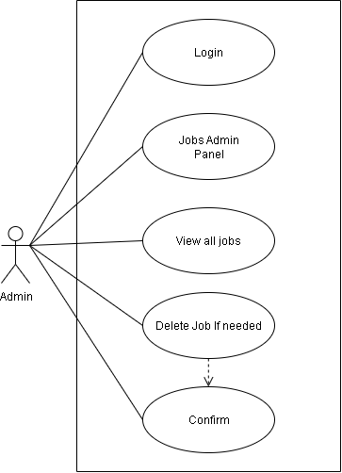

Figure 3.14: View All Jobs and Delete Job Use Case

Chapter 4: Project Design Specification

System Architecture Diagram
The architecture of the HIRED Job Portal follows a modern and scalable structure by separating the frontend, backend, and database. The frontend is built using React 18 and styled with Tailwind CSS, handling all user interactions like registration, login, job browsing, and applications. It connects to Supabase and Clerk through secure API calls. Clerk manages authentication and role based access (candidate, recruiter, admin), while Supabase handles all data storage using PostgreSQL with Row Level Security. Admin only operations are processed through a custom Express.js server to perform elevated tasks like user and job deletion. File uploads (resumes, logos) are stored securely in Supabase Storage. This architecture ensures clean separation of concerns, real time updates, and secure communication between all components.

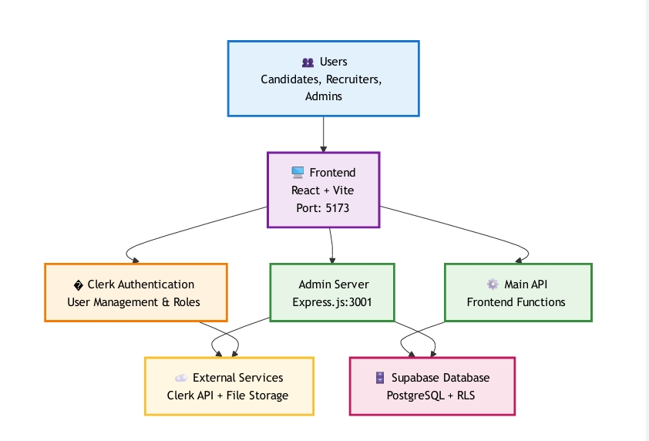

Figure 4.1: System Architecture Diagram

Data Flow Diagram
The Data Flow Diagram (DFD) helps us understand how data moves within the HIRED Job Portal. It shows how users interact with the system and how information flows between components.

Data Flow Diagram (DFD) Level 0

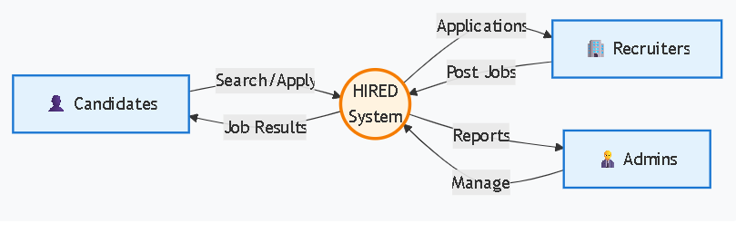
Figure 4.2: Data Flow Level 0 Diagram

Data Flow Diagram (DFD) Level 1

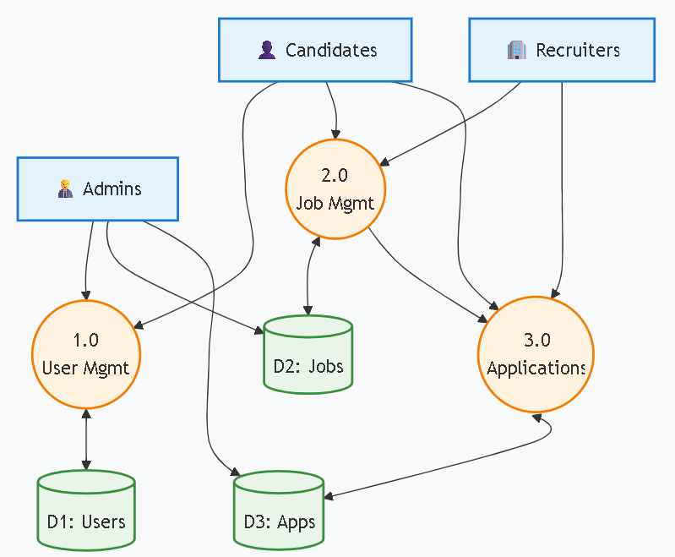
Figure 4.3: Data Flow Level 1 Diagram

Data Flow Diagram (DFD) Level 2

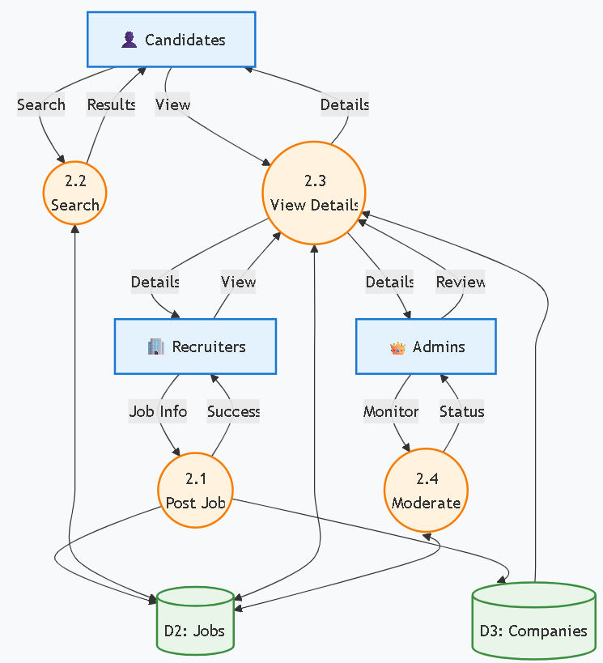

Figure 4.4: Data Flow Level 2 Diagram

Entity Relationship Diagram (ERD)
This diagram shows the database entities and their relationships in the HIRED job portal system.

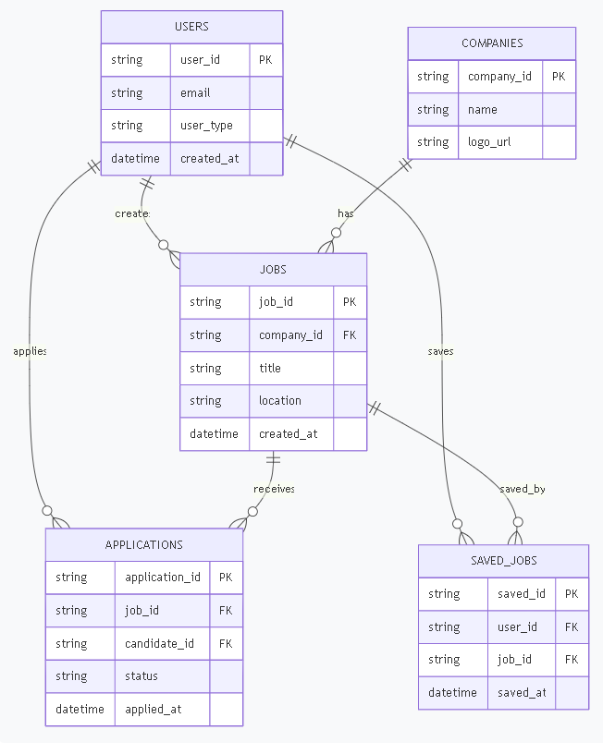

Figure 4.5: Entity Relationship Diagram

Class Diagram
This diagram shows the main classes, their attributes, methods, and relationships in the HIRED job portal system.

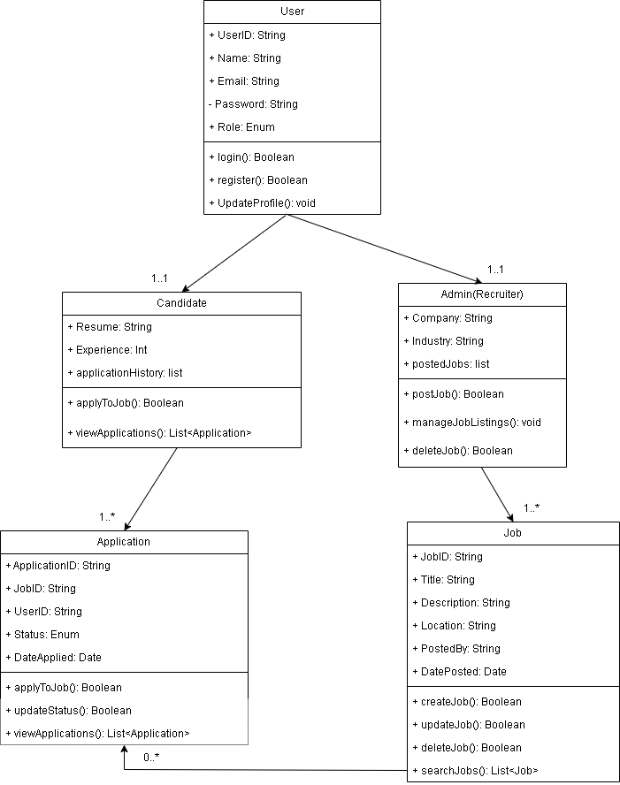

Figure 4.6: Class Diagram of Job Portal

Sequence Diagrams

A Sequence Diagram is a visual representation that shows how different parts of a system interact over time, with messages exchanged between users, APIs, and databases in a step by step order. It helps understand how the system works, identify dependencies, and fix issues.

Candidate Authentication & Onboarding Sequence Diagram

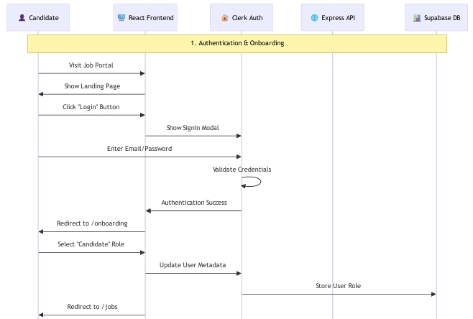

Figure 4.7: Candidate Sequence Diagram

Candidate Job Search & Discovery Sequence Diagram

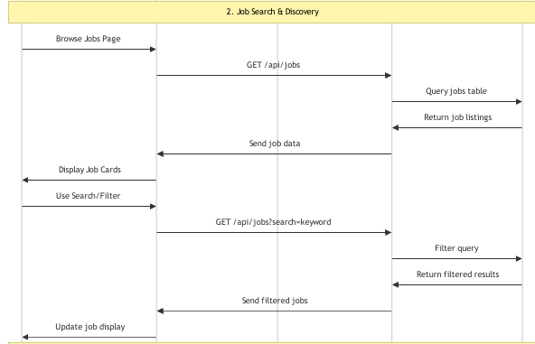
Figure 4.8: Job Search & Discovery Sequence Diagram

Candidate Job Application Process Sequence Diagram

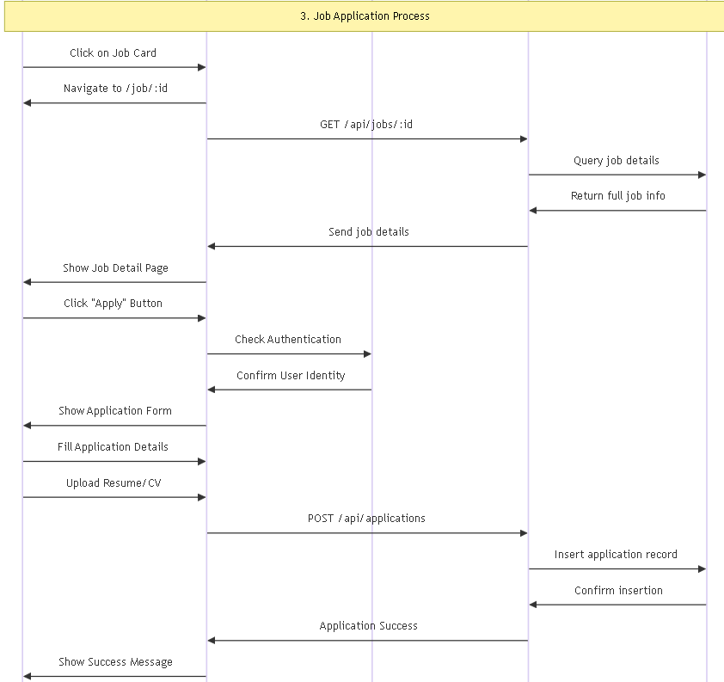
Figure 4.9: Job Search & Discovery Sequence Diagram

Profile Management Sequence Diagram

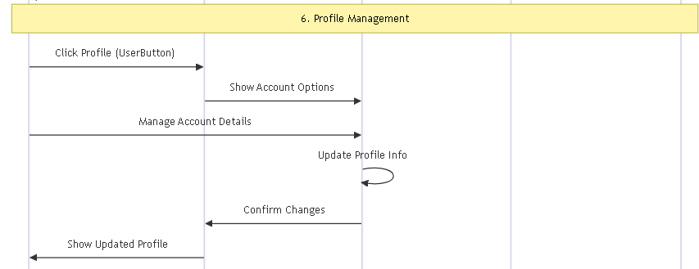
Figure 4.10: Profile Management Sequence Diagram

Recruiter Profile Management Sequence Diagram

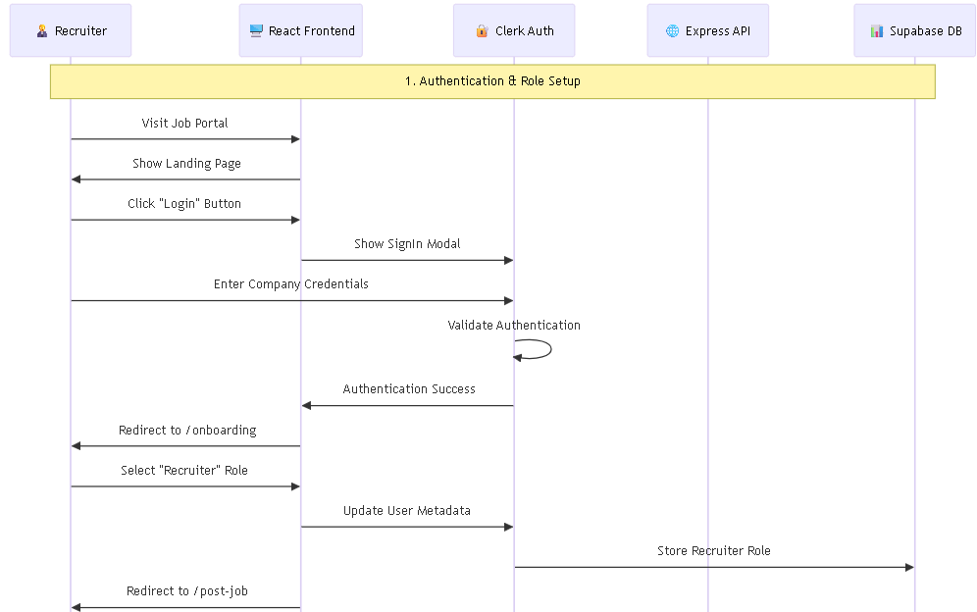
Figure 4.11: Recruiter Profile Management Sequence Diagram

Recruiter Job Posting Process Sequence Diagram

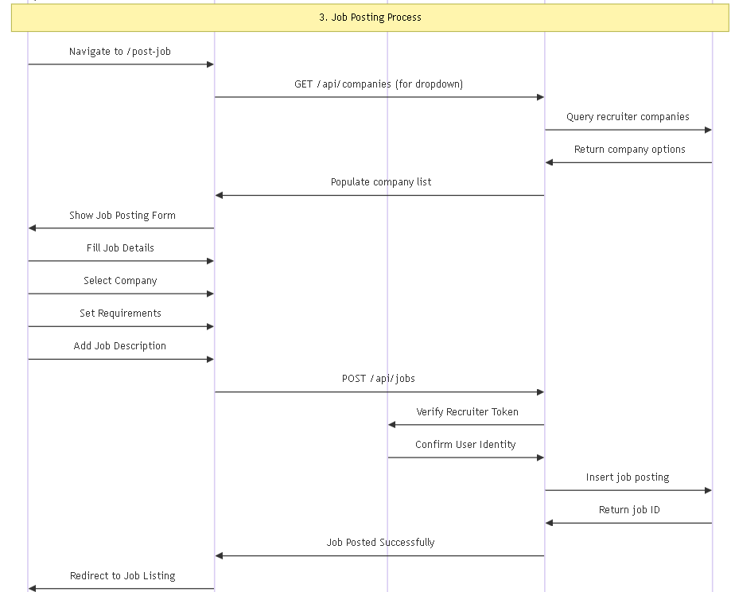
Figure 4.12: Recruiter Job Posting Process Sequence Diagram

Recruiter Application Status Updates Sequence Diagram

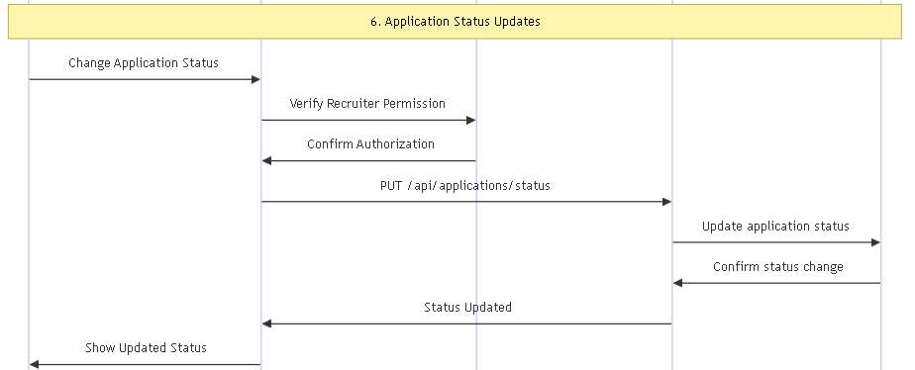
Figure 4.13: Recruiter Application Status Updates Sequence Diagram

Admin Authentication & Access Sequence Diagram

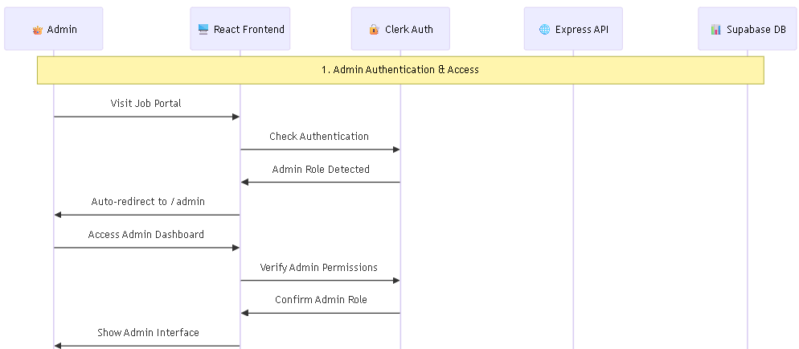
Figure 4.14: Admin Authentication & Access Sequence Diagram

Admin User Account Management Sequence Diagram

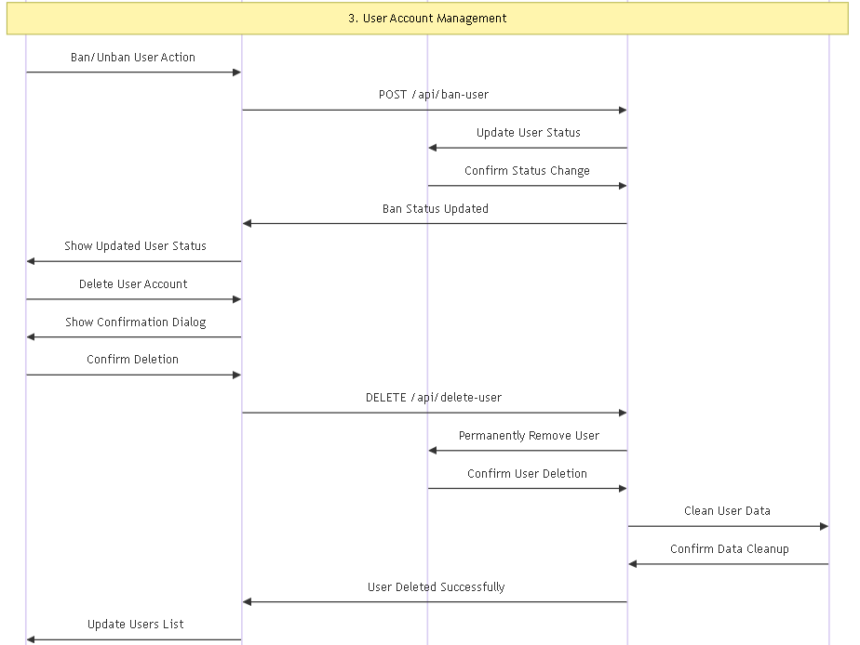
Figure 4.15: Admin User Account Management Sequence Diagram

Admin Job Postings Oversight/Delete Sequence Diagram

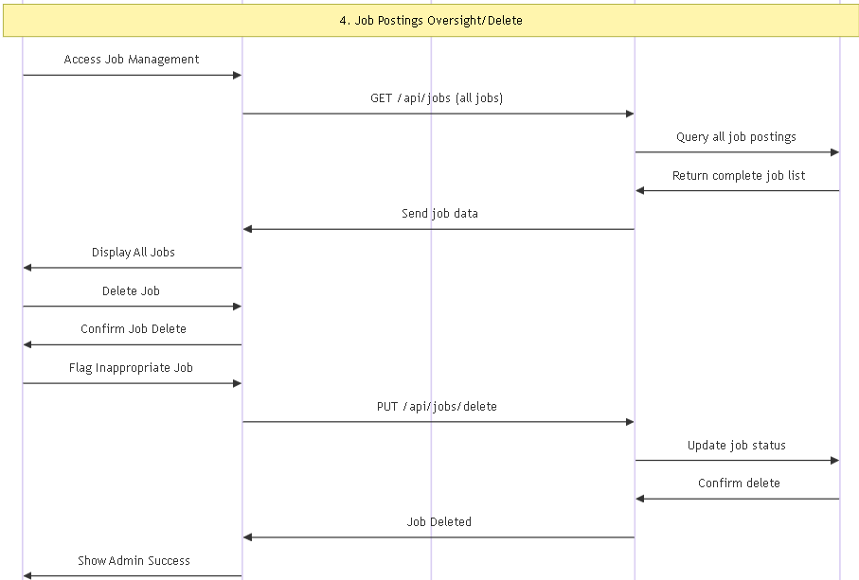
Figure 4.16: Admin Job Postings Oversight/Delete Sequence Diagram

Recruiter Application Review Process Sequence Diagram

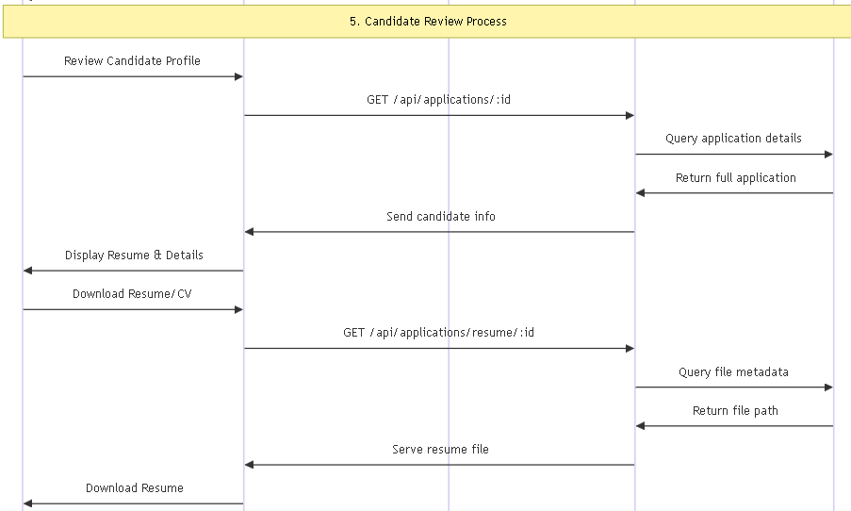
Figure 4.17: Admin Job Postings Oversight/Delete Sequence Diagram

Collaboration Diagram
A Collaboration Diagram, also called a Communication Diagram, is similar to a Sequence Diagram but focuses on how objects work together to perform a task rather than the order of messages over time. It shows the interactions between objects to achieve a specific function.

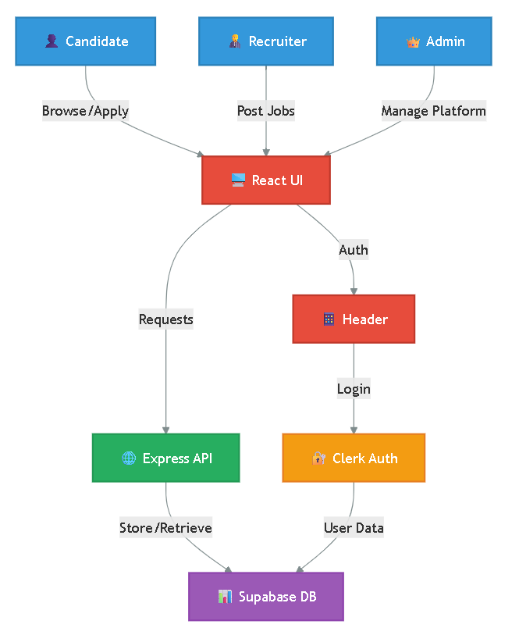

Figure 4.18: Collaboration Diagram

Activity Diagram

An Activity Diagram represents the step by step workflow of key processes in the system. It provides a clear visualization of how tasks flow from start to finish, including decision points, parallel actions, and final outcomes.

Candidate Activity Diagram

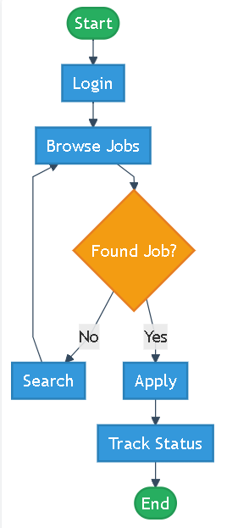

Figure 4.19: Candidate Activity Diagram

Recruiter Activity Diagram

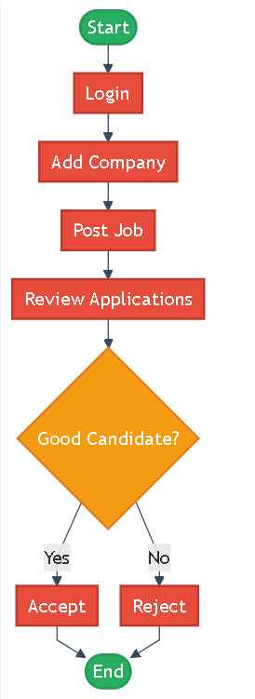

Figure 4.20: Recruiter Activity Diagram

Admin Activity Diagram

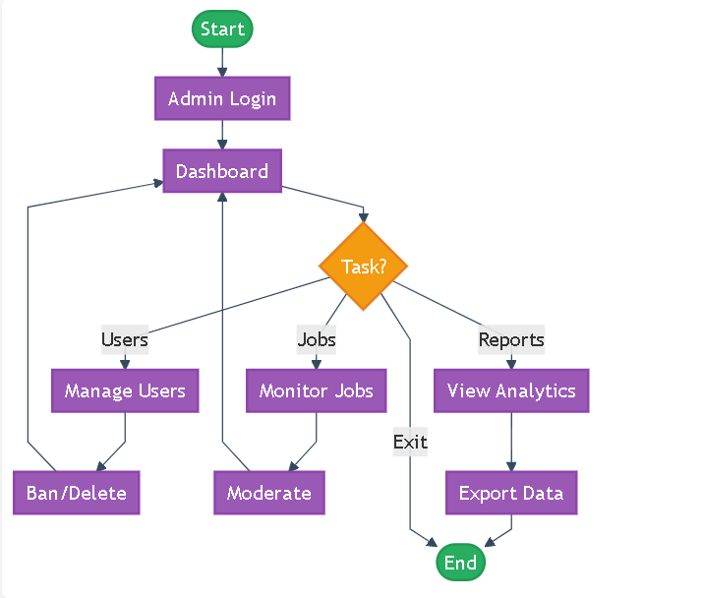

Figure 4.21: Recruiter Activity Diagram

State Transition Diagram

A State Transition Diagram shows how different entities in a system change states based on user actions or system events. In the Full Stack Job Portal, this is important for managing the lifecycle of job applications, user accounts, and job listings.

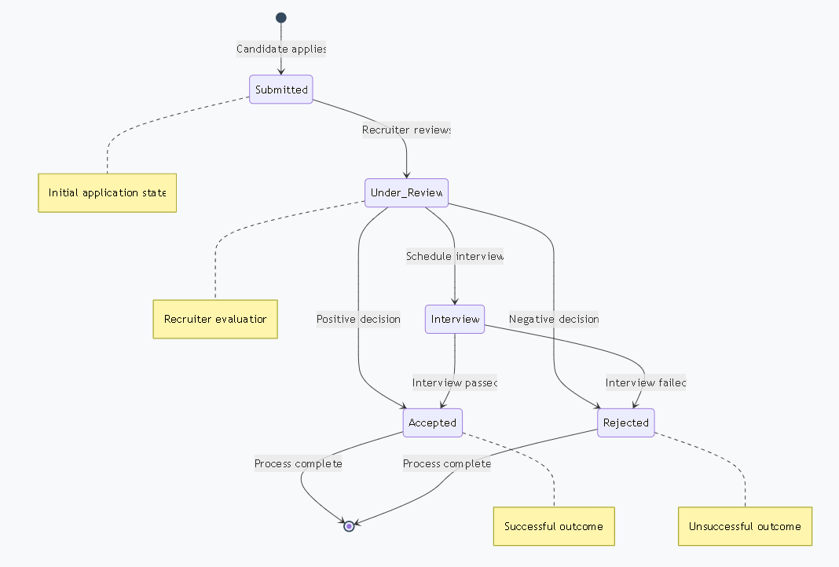

Figure 4.13: State Transition Diagram

Component Diagram
Component Design is an important part of building a system, where different software parts are organized into separate modules that each do specific tasks. This makes the system more manageable, scalable, and easy to expand. By having clear, well defined components, developers can ensure that the system runs smoothly and is easier to fix or improve in the future.

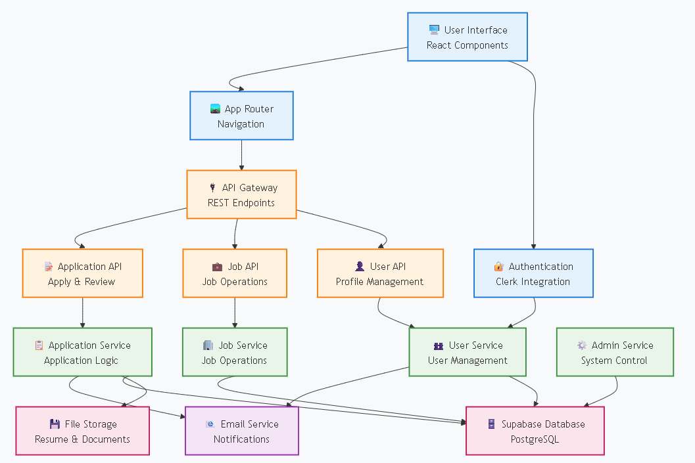

Figure 4.12: Component Diagram

Chapter 5: Testing and Implementation

Project Testing
Testing makes sure the Full Stack Job Portal works as expected in different situations. It checks that all features, like job posting and application tracking, function correctly, while also finding and fixing bugs, security problems, and performance issues. Testing ensures the system meets all requirements and provides a smooth user experience, with good responsiveness and stability.

Types of Testing Performed on Job Portal
To make sure the Full Stack Job Portal works well and is safe to use, different types of testing are done. Unit testing checks each function or part by itself. Integration testing makes sure all parts like frontend, backend, and database work together. System testing checks the whole portal to see if everything works properly. User Acceptance Testing is done by real users to see if the portal is easy to use and meets needs. Performance testing checks how fast and stable the system is when many users are active.

Test Cases and Scenarios
Testing is an important part of the Full Stack Job Portal to make sure everything works properly and gives users a smooth experience. It includes checking both how features work (functional tests) and how well the system performs (non-functional tests). Each test has a unique ID, a short description, what needs to be set before the test, what should happen, what actually happened, and if the test passed or failed.

Functional Test Cases
Functional test cases help check if the system features work the way they should, like user registration, job posting, applying for jobs, and managing accounts. These tests use different inputs to see if the system gives the right results.

User Registration Test Case

Test Case ID | TC_01
Description | Verify that a new user can register successfully.
Preconditions | The user must have a valid email address and internet connection.
Expected Output | User account is created, and the system confirms email verification.
Actual Output | User registered successfully.
Status | Passed
Table 5.1: User Registration Test Case Table

User Login Test Case

Test Case ID | TC_02
Description | Ensure that users can log in with valid credentials.
Preconditions | The user must have a registered and verified account.
Expected Output | User account is created, and the system confirms email verification.
Actual Output | User successfully logs into the dashboard.
Status | Passed
Table 5.2: User Login Test Case Table

Job Posting Test Case (For Recruiters)

Test Case ID | TC_03
Description | Verify that recruiters can post job listings successfully.
Preconditions | The recruiter must be logged into their account.
Expected Output | Job listing appears in the job search database.
Actual Output | Job posted successfully.
Status | Passed
Table 5.3: Job Posting Test Case Table

Job Search Test Case (For Job Seekers)

Test Case ID | TC_04
Description | Ensure job seekers can search for relevant jobs.
Preconditions | There must be active job listings in the system.
Expected Output | Relevant job listings appear based on the search criteria.
Actual Output | Job search displays correct results.
Status | Passed
Table 5.4: Job Search Test Case (For Job Seekers) Table

Job Application Test Case (For Job Seekers)

Test Case ID | TC_05
Description | Ensure job seekers can apply for jobs.
Preconditions | The user must be logged in as a job seeker and have a resume uploaded.
Expected Output | Application is stored in the database, and the recruiter is notified.
Actual Output | Application submitted successfully.
Status | Passed
Table 5.5: Job Application Test Case (For Job Seekers) Table

Block/Unblock User (Admin)

Test Case ID | TC_06
Description | Verify that an admin can block or unblock a user successfully.
Preconditions | Admin must be logged in with valid credentials and have admin role access.
Expected Output | Selected user account is blocked/unblocked, and the status is updated in the system. Blocked users cannot log in until unblocked.
Actual Output | User was blocked/unblocked successfully.
Status | Passed
Table 5.6: Block/Unblock User (Admin) Table

Delete User (Admin)

Test Case ID | TC_07
Description | Verify that an admin can delete a user from the system.
Preconditions | Admin must be logged in with valid credentials and have admin role access.
Expected Output | User account is permanently removed from the database, and all related data is handled as per policy.
Actual Output | User deleted successfully.
Status | Passed
Table 5.7: Delete User (Admin) Table

Delete Job (Admin)

Test Case ID | TC_08
Description | Verify that an admin can delete a job posting from the system.
Preconditions | Admin must be logged in and have access to the Jobs tab in the Admin Panel.
Expected Output | Selected job is removed from the job listings database and no longer visible to job seekers.
Actual Output | Job deleted successfully.
Status | Passed
Table 5.8: Delete Job (Admin) Table

Search User/Job by Email (Admin)

Test Case ID | TC_09
Description | Verify that an admin can search for a user or job by email in the admin panel.
Preconditions | Admin must be logged in and have valid email input in the search bar.
Expected Output | System displays matching users or job listings related to the entered email.
Actual Output | Search returned correct matching results.
Status | Passed
Table 5.9: Search User/Job by Email (Admin) Table

Change Job Status (Open/Closed) (Recruiter)

Test Case ID | TC_10
Description | Verify that an admin can search for a user or job by email in the admin panel.
Preconditions | Admin must be logged in and have valid email input in the search bar.
Expected Output | System displays matching users or job listings related to the entered email.
Actual Output | Search returned correct matching results.
Status | Passed
Table 5.10: Change Job Status (Open/Closed) (Recruiter) Table

View Applicants for Job (Recruiter)

Test Case ID | TC_11
Description | Verify that recruiters can view the list of applicants for a specific job posting.
Preconditions | Recruiter must be logged in and own the job posting.
Expected Output | System displays all applicants with details and resumes for that job.
Actual Output | Applicants list displayed successfully.
Status | Passed
Table 5.11: View Applicants for Job (Recruiter) Table

Save Job for Later (Job Seeker)

Test Case ID | TC_12
Description | Verify that a job seeker can save a job to their favorites list.
Preconditions | Job seeker must be logged in.
Expected Output | Job is saved to the user's favorites list for later access.
Actual Output | Job saved successfully.
Status | Passed
Table 5.12: View Applicants for Job (Recruiter) Table

View Saved Jobs (Job Seeker)

Test Case ID | TC_13
Description | Verify that a job seeker can view their saved jobs list.
Preconditions | Job seeker must be logged in and have saved jobs.
Expected Output | System displays all saved jobs for that user.
Actual Output | System displays all saved jobs for that user.
Status | Passed
Table 5.13: View Saved Jobs (Job Seeker) Table

Non Functional Test Cases
Non functional test cases check how well the system performs beyond just working correctly. They test things like speed, security, ease of use, and how the system handles many users at once.

Performance Test Case (System Load Handling)

Test Case ID | TC_NF_01
Description | Ensure the system can handle 1000+ job postings and user interactions without slowdown.
Preconditions | The system must have test data with over 1000 job listings.
Expected Output | The system remains responsive with a response time < 2 seconds.
Actual Output | No performance lag detected.
Status | Passed
Table 5.14: Performance Test Case (System Load Handling) Table

Security Test Case (Unauthorized Access Prevention)

Test Case ID | TC_NF_02
Description | Ensure unauthorized users cannot access restricted data.
Preconditions | The system must have role based access control (RBAC).
Expected Output | The system prevents unauthorized access and shows an error message.
Actual Output | Unauthorized access denied.
Status | Passed
Table 5.15: Security Test Case (Unauthorized Access Prevention) Table

Usability Test Case (Mobile Responsiveness)

Test Case ID | TC_NF_03
Description | Verify that the job portal UI adapts to different screen sizes.
Preconditions | The system must be accessible on desktop, tablet, and mobile devices.
Expected Output | UI adapts to various screen sizes with a smooth user experience.
Actual Output | Mobile responsiveness confirmed.
Status | Passed
Table 5.16: Usability Test Case (Mobile Responsiveness) Table

Project Implementation
The Implementation phase is the final step where the Full Stack Job Portal is launched for real users. This includes setting up the hosting, connecting the frontend and backend, configuring the database, and linking services like authentication and email. The frontend is hosted on Vercel, and the backend uses Supabase, which also handles the database. Clerk Authentication is used for secure login and role management. Before going live, the system was tested to make sure everything worked correctly. APIs for email and file uploads were also added to improve the user experience. After deployment, more testing was done in the live system to check how well it worked under real conditions. The user interface is clean and simple, making it easy for both job seekers and recruiters to use.
Screenshots of pages like the homepage, login, dashboard, and job search are used to show how the system looks and works.

Homepage (Landing Page) Preview

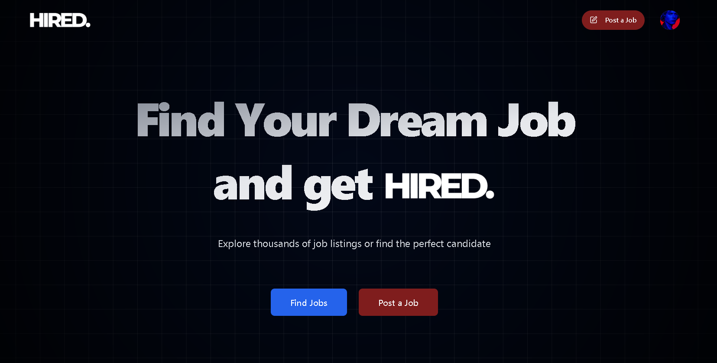

Figure 5.1: Job Portal Homepage (Landing Page) Preview

Registration Page Preview

The Registration Page lets new users sign up as job seekers or recruiters through a simple form that asks for their name, email, password, and role. It uses Clerk Authentication for secure sign up and includes email verification to stop fake accounts. The page is easy to use and works well on both desktop and mobile devices.

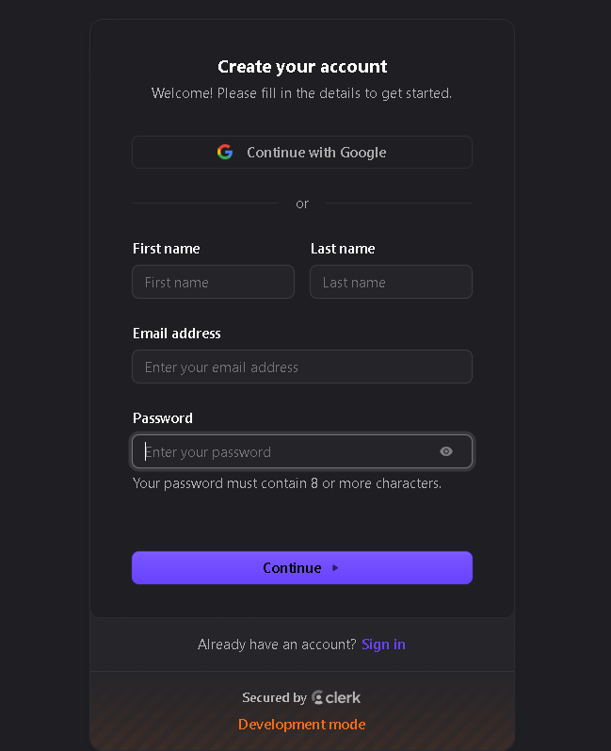

Figure 5.2: Job Portal Registration Page Preview

Login Page Preview

The Login Page lets registered users safely access their accounts by entering their email and password. It also has a password reset option if someone forgets their login details. Clerk Authentication checks the login info to make sure only the right users get in. The page is simple and quick, helping job seekers and recruiters use the portal easily.

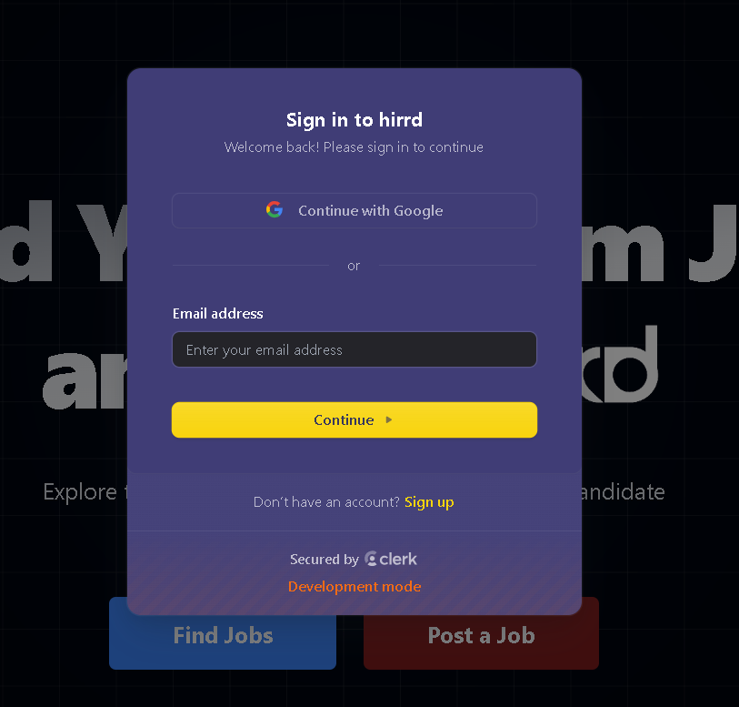

Figure 5.3: Job Portal Login Page Preview

Account Manager Page Preview

The Account Manager Page lets users easily manage their account settings. They can update their profile picture, add a new email, connect their Gmail, and see active login sessions for better security. It also allows them to change their password or delete their account if needed. The page is simple and safe to use, making account management easy for everyone.

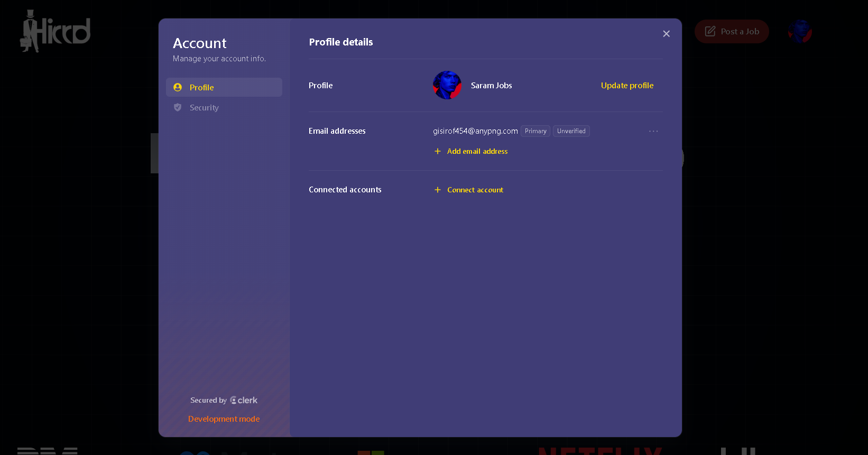

Figure 5.4: Job Portal Account Manager Page Preview

Jobs Page Preview

The Jobs Page is where users can search for job listings. They can filter jobs by title, category, location, and company. Each job post shows important details like the description, required skills, and deadlines, helping job seekers find the right opportunities. The page is easy to navigate and designed for quick searches, providing a smooth experience.

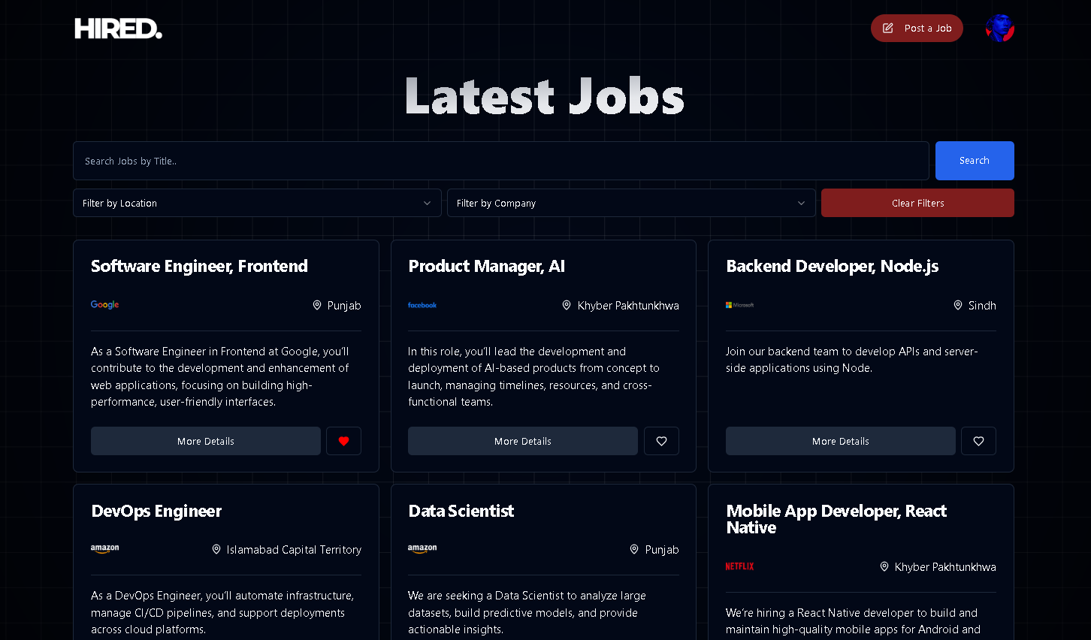

Figure 5.5: Job Portal Jobs Page Preview

Posting Job Page Preview

The Posting Job Page allows recruiters to create new job listings by filling out a form with details like title, description, experience required, location, salary, and company. Once submitted, the job is published and visible to job seekers. The system ensures only authorized recruiters can post jobs, keeping the platform secure and data intact.

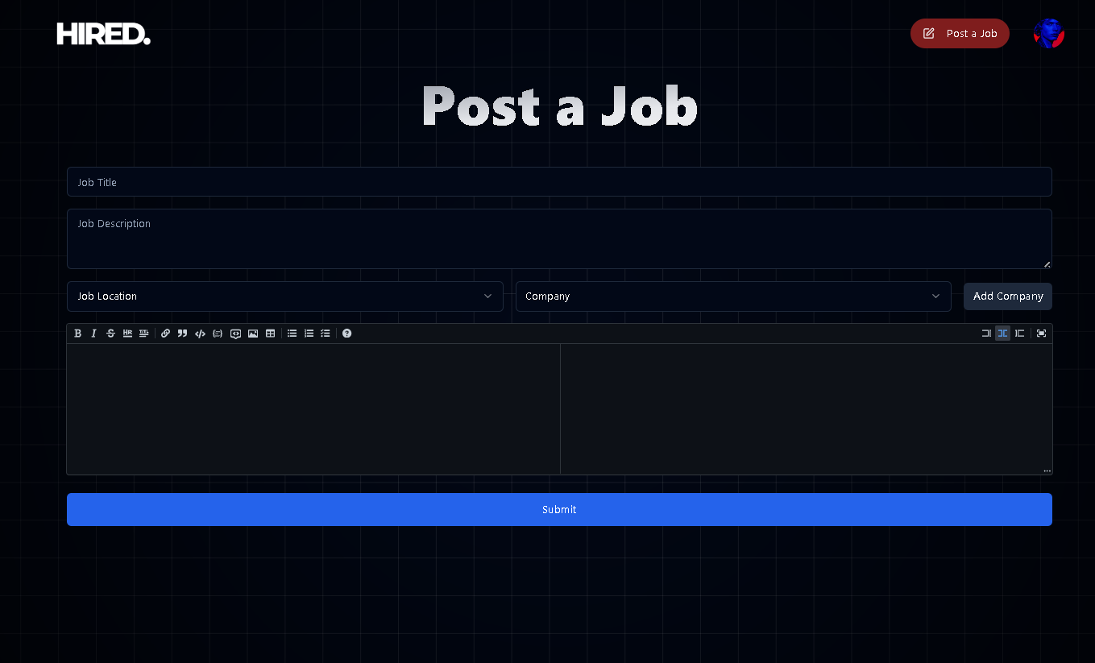

Figure 5.6: Job Portal Posting Job Page Preview

Managing Applications Page Preview

The Managing Applications Page lets recruiters view and manage job applications. It shows a list of applicants with their resumes and application statuses. Recruiters can shortlist candidates, schedule interviews, or update statuses like Applied, Interview, Hired, or Rejected. This page makes the hiring process easier by helping recruiters track and communicate with applicants efficiently.

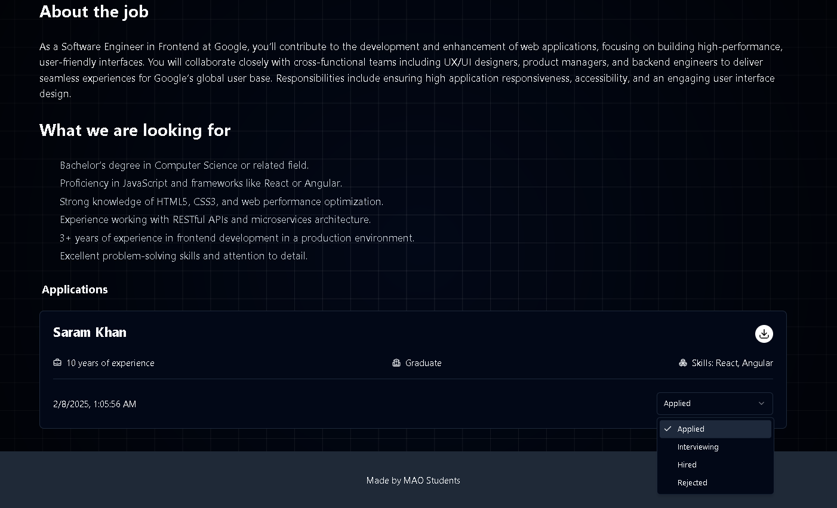

Figure 5.7: Job Portal Managing Applications Page Preview

Manage Jobs Delete/Update Page Preview

The Manage Jobs Page gives recruiters a simple dashboard to edit, update, or remove job postings. Recruiters can see all active job listings and make changes when needed. If a job is no longer available, they can close or delete it, ensuring the platform always shows current job opportunities for seekers.

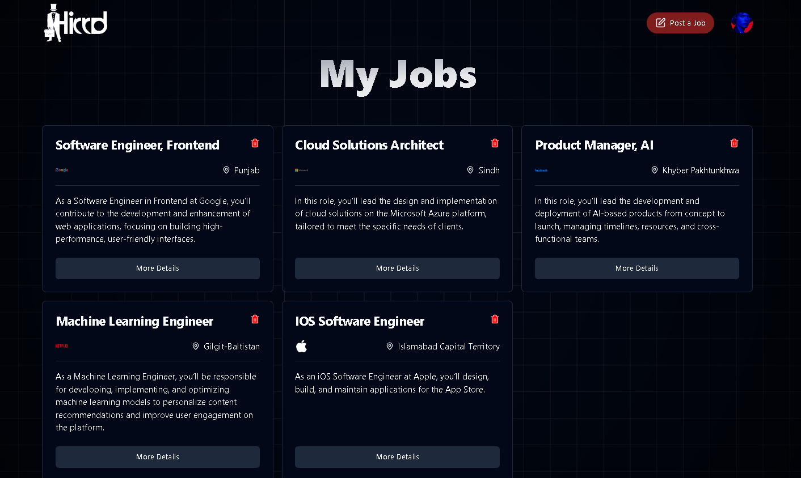

Figure 5.8: Job Portal Manage Jobs Delete/Update Page Preview

Saved Jobs Page Preview

The Saved Jobs Page allows job seekers to view all the jobs they have bookmarked for later. Each saved job shows key details like title, company name, and location, with quick links to view the full posting or apply directly. This feature helps users keep track of opportunities they are interested in without needing to search for them again. The page is simple, well-organized, and works smoothly on both desktop and mobile devices.

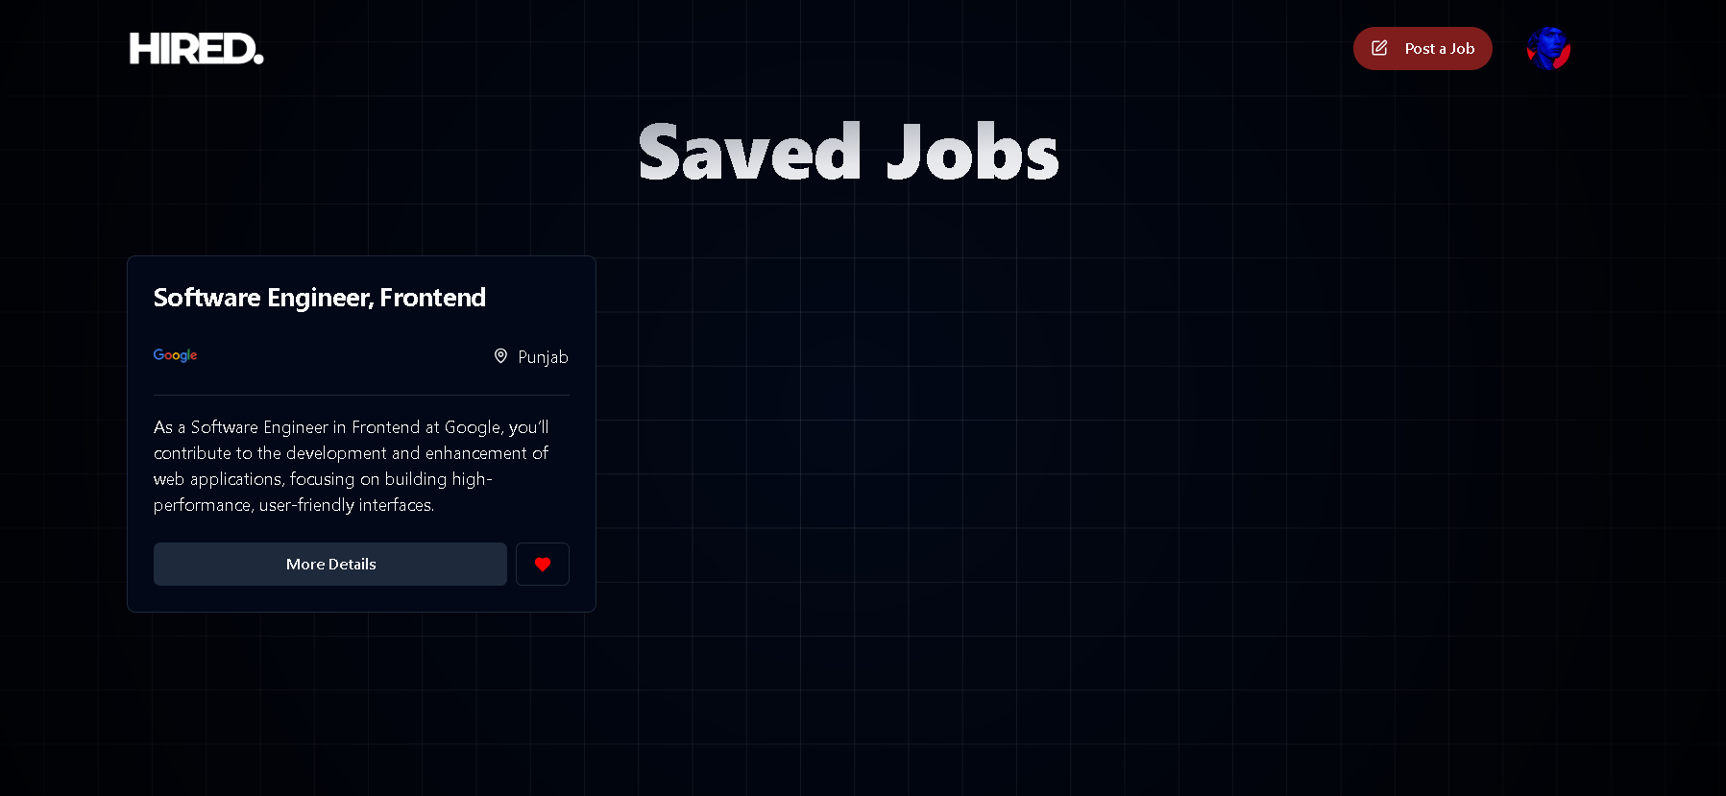

Figure 5.9: Saved Jobs Page Preview

Admin Pannel User Manager Page Preview

The Admin Panel User Manager Page gives administrators full control over platform users. It displays a searchable list of all registered users along with their roles, email addresses, and account status. From here, admins can block or unblock users, delete accounts, and search for users quickly using their email. This page ensures smooth user management, helping maintain security, prevent misuse, and keep the platform running efficiently.

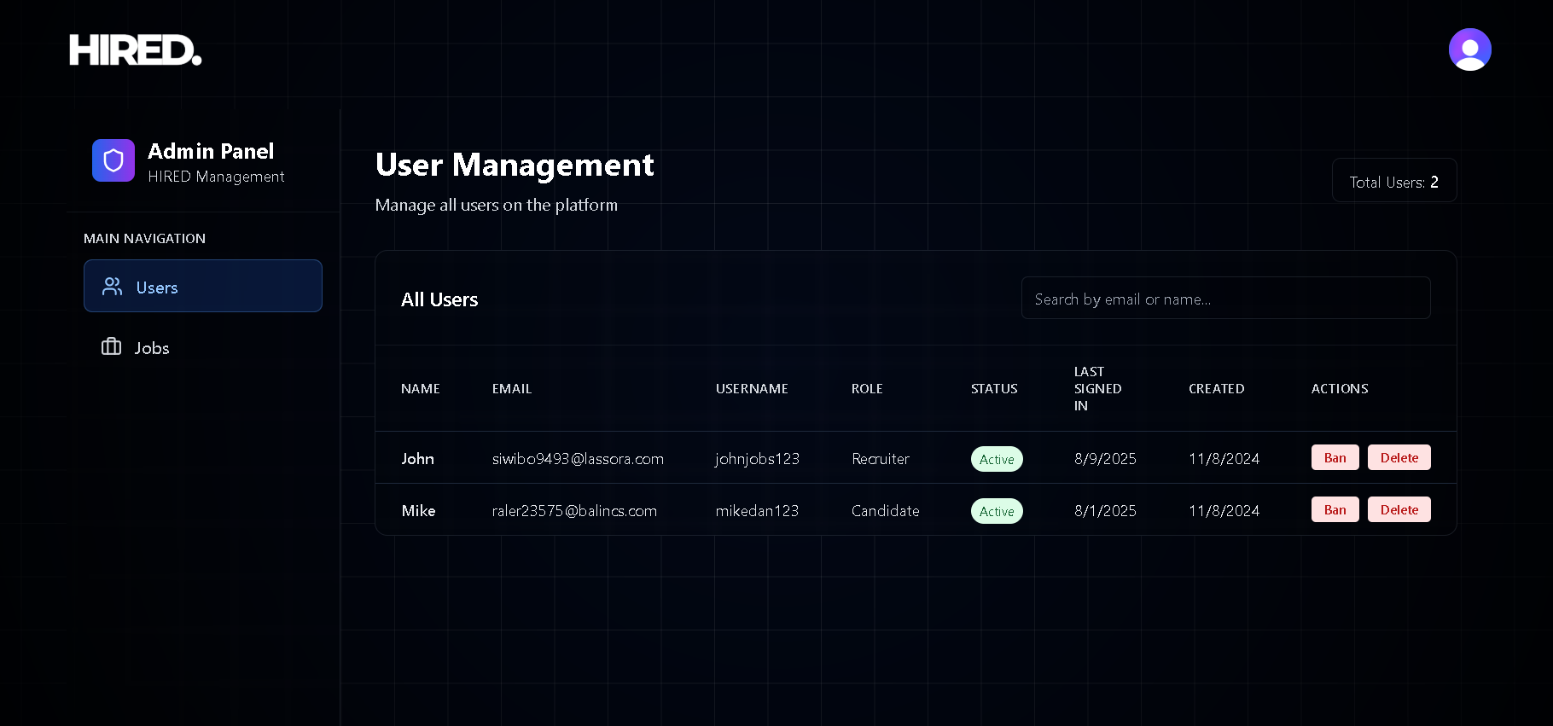

Figure 5.10: Admin Pannel User Manager Page Preview

Admin Pannel Jobs Manager Page Preview

The Admin Panel Jobs Manager Page allows administrators to oversee and manage all job postings on the platform. It shows a searchable list of jobs with details like title, recruiter email, and status. Admins can quickly find specific jobs using the recruiter’s email, delete inappropriate or expired postings, and ensure that only relevant, up to date opportunities are available to job seekers. This page helps maintain the quality and credibility of the platform’s job listings.

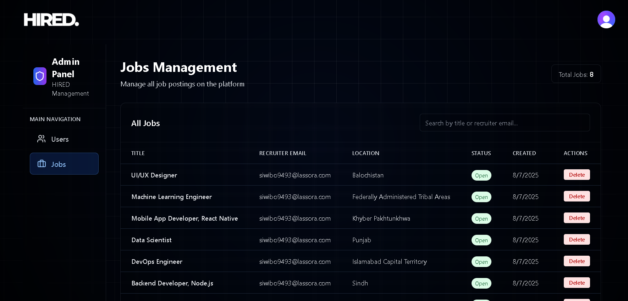

Figure 5.11: Admin Pannel Jobs Manager Page Preview

Chapter 6: Deployment & Maintenance

Introduction to Deployment & Maintenance
The Deployment & Maintenance phase makes sure the Full Stack Job Portal is successfully launched and stays secure, efficient, and updated. Deployment involves setting up hosting, servers, and integrating services, while maintenance focuses on fixing bugs, updating security, and improving performance. This phase includes strategies for deployment, system configurations, security, and long term maintenance to keep the platform running smoothly and ready for future upgrades.

Deployment Diagram
The Deployment Diagram shows how the system's components work together in the hosting environment.

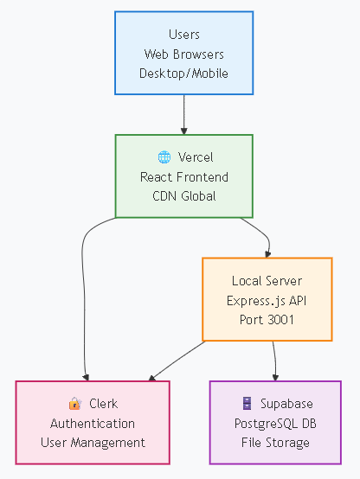

Figure 6.1: Job Portal Deployment Diagram

Database Configuration & Data Migration

A well organized database is key to managing user accounts, job listings, applications, and recruiter profiles. Supabase, a cloud based PostgreSQL database, was used for its security, scalability, and real time syncing. Tables like Users, Jobs, Applications, and Recruiters were set up with indexes and relationships for fast data retrieval. Before going live, test data was imported, backups were created, and security measures like role based access and encryption were applied. The database was thoroughly tested to ensure smooth operations like job searches, application tracking, and recruiter interactions.

Security & Compliance During Deployment
Security is crucial in protecting user data, job listings, and recruiter information. Clerk Authentication was set up with email verification, session management, and JWT-based login to keep accounts secure. Supabase has secure rules that limit access based on user roles, while HTTPS encryption, API authentication, and data validation protect against threats. Regular security audits are done to spot and fix vulnerabilities, ensuring the system follows privacy rules and security standards.

API Integration & Cloud Services
The Full Stack Job Portal uses third party services to improve its functionality. Clerk API manages user authentication securely, the Email API sends job application updates and verification emails, and the File Storage API handles secure resume and logo uploads. These integrations make the system more reliable, reduce server load, and improve the user experience. Each API was carefully tested to ensure smooth data handling and error free operation.

Post Deployment Monitoring & Analytics
After launch, the system is continuously monitored to track performance, uptime, and user activity. Tools like Supabase monitoring, server logs, and analytics dashboards help identify issues early, track admin actions (like user bans or job deletions), and ensure stable performance.

Backup & Disaster Recovery Plan

Regular database backups are scheduled in Supabase to prevent data loss. In case of accidental deletion, security breach, or system failure, backups can be restored quickly. This ensures the platform remains reliable for candidates, recruiters, and admins.

Update & Feature Rollout Process
When adding new features (like the Admin Panel, search by email, or advanced filters), updates are first tested in a staging environment before being deployed live. This process prevents downtime and ensures smooth user experience.

Maintenance of Security Policies
Security rules in Supabase and Clerk are reviewed periodically to adapt to new threats. Admin activities are logged for accountability, and outdated dependencies are updated to avoid vulnerabilities.

Final Testing Before Launch
Before the final deployment, thorough testing was done to ensure the system worked well in a real world setting. Tests included job searches, applications, recruiter postings, and user logins. Performance tests checked how the system handled heavy traffic, ensuring it worked smoothly with many users. After fixing minor issues and making UI improvements, the system was officially launched for users.

References

[1] Freeman, E., & Robson, E. Head First Design Patterns: A Brain-Friendly Guide. O'Reilly Media, 2020.

[2] Flanagan, D. JavaScript: The Definitive Guide. O'Reilly Media, 2020.

[3] Wieruch, R. The Road to React: Your Journey to Master React.js in JavaScript. Independently Published, 2019.

[4] Tachibana, A. Full-Stack Web Development with React, TypeScript, and Node. Packt Publishing, 2021.

[5] MDN Web Docs. React.js Documentation. Mozilla Developer Network (MDN). Available: https://developer.mozilla.org/, 2024.

[6] Vercel Docs. Deploying React Applications on Vercel. Vercel Documentation. Available: https://vercel.com/docs, 2024.

[7] Tailwind CSS Docs. Tailwind CSS Guide. Tailwind CSS Official Documentation. Available: https://tailwindcss.com/docs, 2024.

[8] React Docs. Official React Documentation. Meta Open Source. Available: https://react.dev, 2024.

[9] Wieruch, R. Advanced React Patterns and Techniques. Independently Published, 2020.

[10] Stack Overflow. Common React Errors and Solutions. Stack Overflow Community. Available: https://stackoverflow.com, 2024.

[11] Supabase Docs. Building a Scalable Backend with Supabase. Supabase Documentation. Available: https://supabase.com/docs, 2024.

[12] PostgreSQL Docs. PostgreSQL Database Management Best Practices. PostgreSQL Official Documentation. Available: https://www.postgresql.org/docs/, 2024.

[13] Express.js Docs. Official Express.js Guide. Node.js Foundation. Available: https://expressjs.com/, 2024.

[14] Node.js Docs. Official Node.js Documentation. Node.js Foundation. Available: https://nodejs.org/en/docs/, 2024.
[15] Supabase Blog. Real-time Database with Supabase. Supabase Blog. Available: https://supabase.com/blog, 2023.

[16] Clerk Docs. User Authentication in React Apps. Clerk Developer Documentation. Available: https://clerk.dev/docs, 2024.

[17] OWASP Foundation. Top 10 Web Security Risks. Open Web Application Security Project (OWASP). Available: https://owasp.org/www-project-top-ten/, 2024.

[18] JWT.io. JSON Web Tokens (JWT) Explained. JWT Open Standard. Available: https://jwt.io/, 2024.

[19] IBM Security. Role-Based Access Control (RBAC) in Web Applications. IBM Security Research. Available: https://www.ibm.com/security/, 2023.

[20] NIST. Cybersecurity Guidelines for Web Applications. National Institute of Standards and Technology (NIST). Available: https://www.nist.gov/cybersecurity, 2024.

[21] REST API Guidelines. Best Practices for REST API Development. REST API Design Principles. Available: https://restfulapi.net/, 2024.

[22] Twilio Docs. Integrating Email & SMS Notifications in Web Applications. Twilio API Documentation. Available: https://www.twilio.com/docs, 2024.

[23] Firebase Docs. Cloud Storage for Web Apps. Google Firebase Documentation. Available: https://firebase.google.com/docs/storage, 2024.

[24] GitHub Docs. Version Control and CI/CD Deployment Strategies. GitHub Documentation. Available: https://docs.github.com/, 2024.

[25] Cloudflare Docs. Enhancing API Security with Rate Limiting & CORS. Cloudflare Developer Documentation. Available: https://developers.cloudflare.com, 2024.

